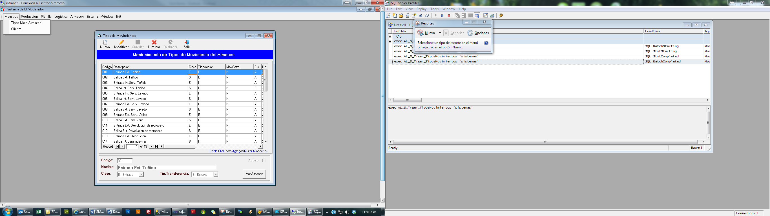

exec AL_S_Traer_TiposMovimientos 'sistemas'

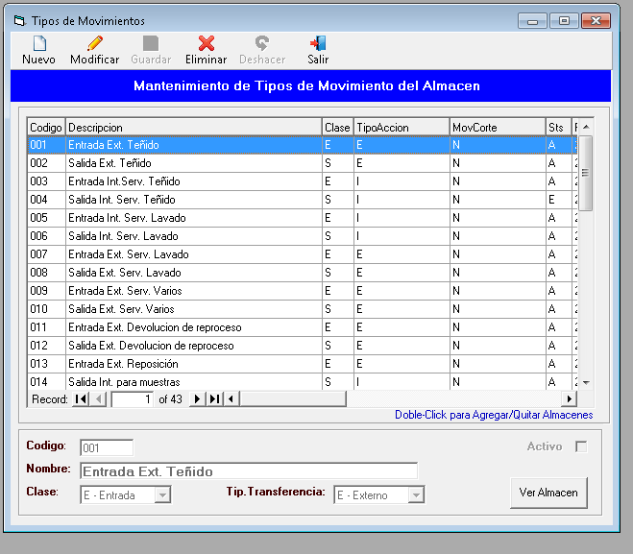

select B.codalmacen,A.a1_cdescri from RSFACCAR..AL0001ALMA A INNER JOIN AL_TipoMovxAlmacen B ON(A.a1_calma=B.CodAlmacen) Where b.codtipomov='001' order by

a1_cdescri

select a1_calma,a1_cdescri from RSFACCAR..AL0001ALMA Where a1_calma not in(select codalmacen from AL_TipoMovxAlmacen Where codtipomov='001') order by a1_cdescri



exec MG_S_Traer_clientes

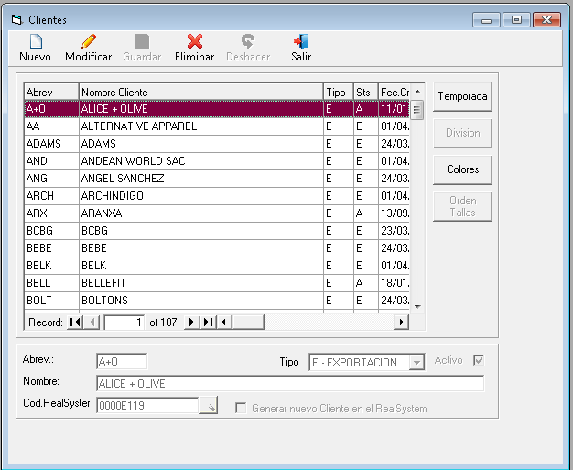

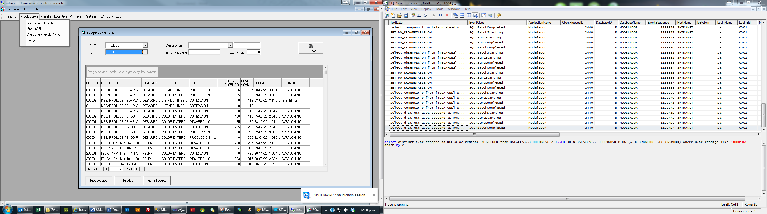

(select descripcion+space(100)+codigo from TIPTEL) union (Select ' - TODOS - ') ORDER BY 1

exec TL_S_BuscaTelas ' ',' ','','','AND','',0

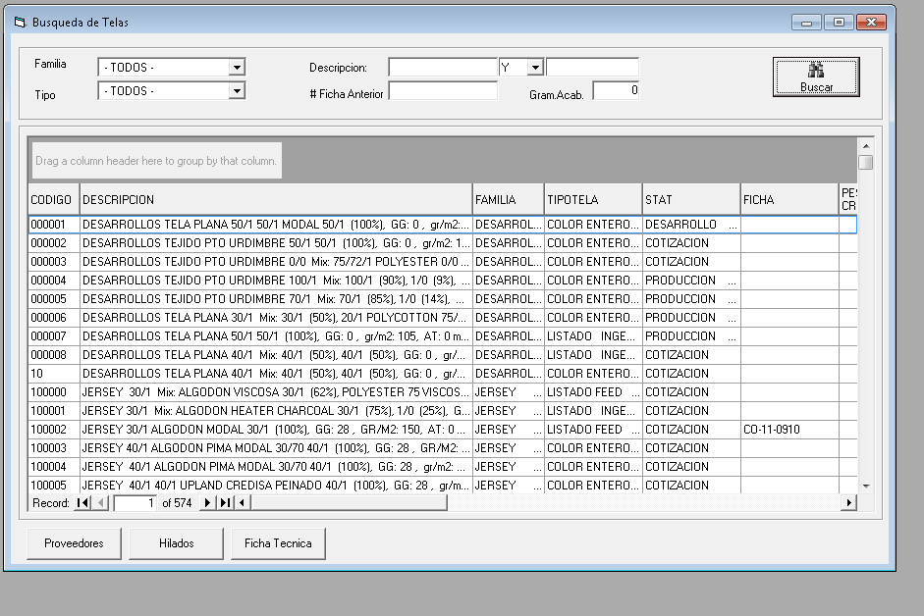

select distinct a.oc_ccodpro as RUC,a.oc_crazsoc PROVEEDOR from RSFACCAR..CO0001MOVC A INNER JOIN RSFACCAR..CO0001MOVD B ON (A.OC_CNUMORD=B.OC_CNUMORD) where b.oc_ccodigo like '000001%'

order by 2

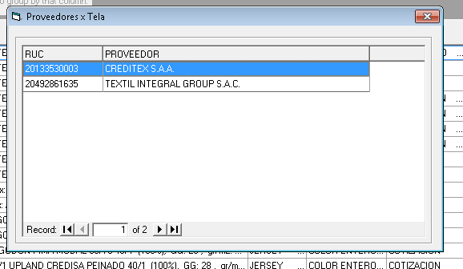

(SELECT HIL1 AS CODIGO,B.DESCRIPCION,POR1 AS [%] FROM TELAS A INNER JOIN HILADO B ON(HIL1=HILO) where tela='000001') union (SELECT HIL2,B.DESCRIPCION,POR2 FROM TELAS A INNER JOIN HILADO B

ON(HIL2=HILO) where tela='000001' and hil2<>'') union (SELECT HIL3,B.DESCRIPCION,POR3 FROM TELAS A INNER JOIN HILADO B ON(HIL3=HILO) where tela='000001' and hil3<>'' ) union (SELECT

HIL4,B.DESCRIPCION,POR4 FROM TELAS A INNER JOIN HILADO B ON(HIL4=HILO) where tela='000001' and hil4<>'' ) union (SELECT HIL5,B.DESCRIPCION,POR5 FROM TELAS A INNER JOIN HILADO B ON(HIL5=HILO)

where tela='000001' and hil5<>'' ) union (SELECT HIL6,B.DESCRIPCION,POR6 FROM TELAS A INNER JOIN HILADO B ON(HIL6=HILO) where tela='000001' and hil6<>'' )

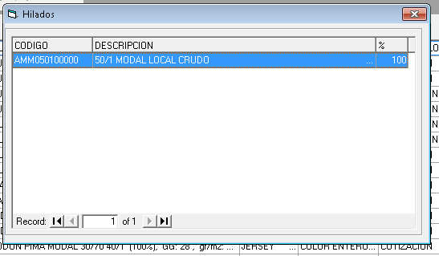

select Version, Descriptor,usuario,fecha from TELARUTAHEAD where estado='A' and tela='000001' order by 2

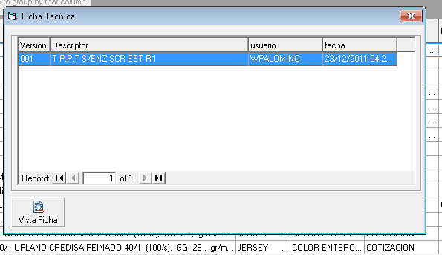

Es la FICHA de la Intranet…..

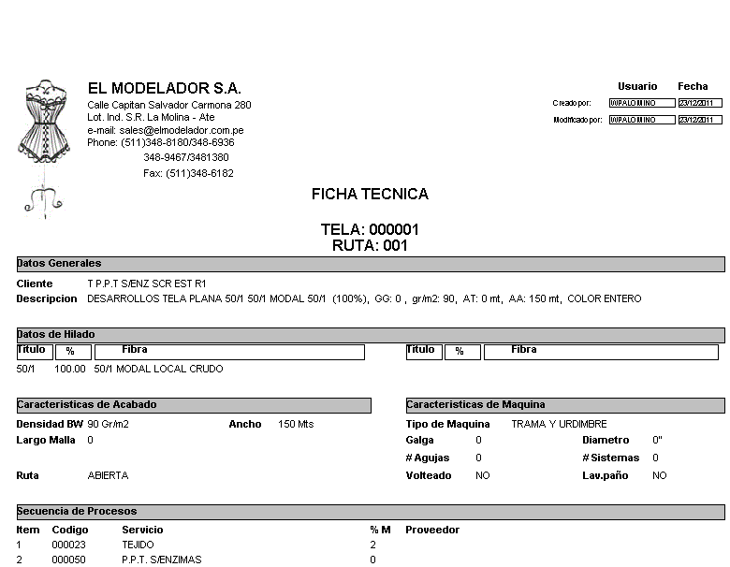

**El resto de opciones de Produción NO FUNCIONAN**

* Busca Ofi
* Actualización de Corte
* Estilo

**Las opciones de planilla tampoco funcionan**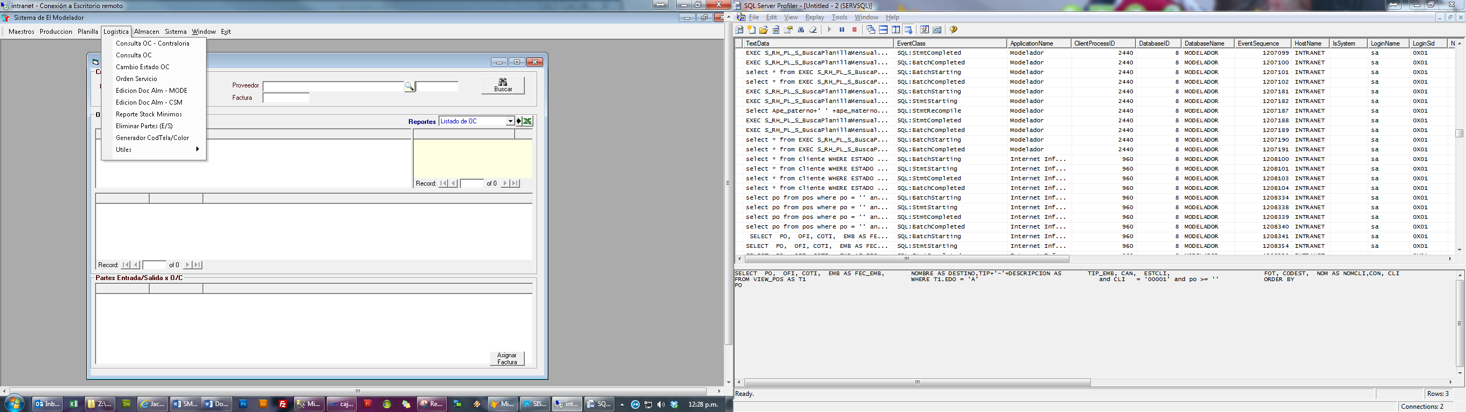

SELECT PO, OFI, COTI, EMB AS FEC_EMB, NOMBRE AS DESTINO,TIP+'-'+DESCRIPCION AS TIP_EMB, CAN, ESTCLI, FOT, CODEST, NOM AS NOMCLI,CON, CLI

FROM VIEW_POS AS T1 WHERE T1.EDO = 'A' and CLI = '00001' and po >= '' ORDER BY

PO

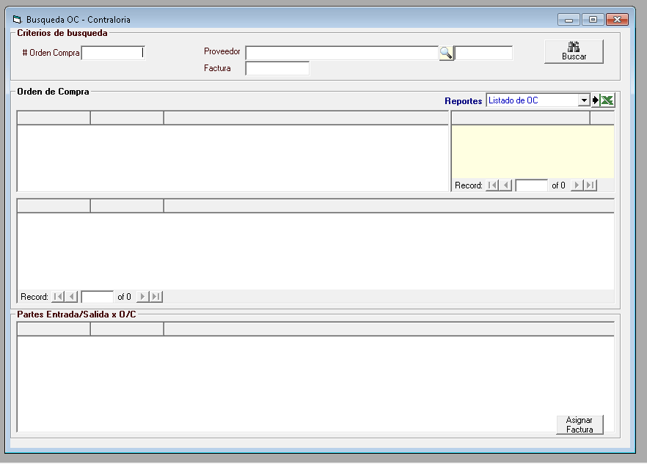

EXEC RS_OC_S_BuscaOC_x_OpcionPrincipal_Contralor '','',''

EXEC S_RS_OC_S_BuscaProveedor_x_DescripcionLike '','','AND'

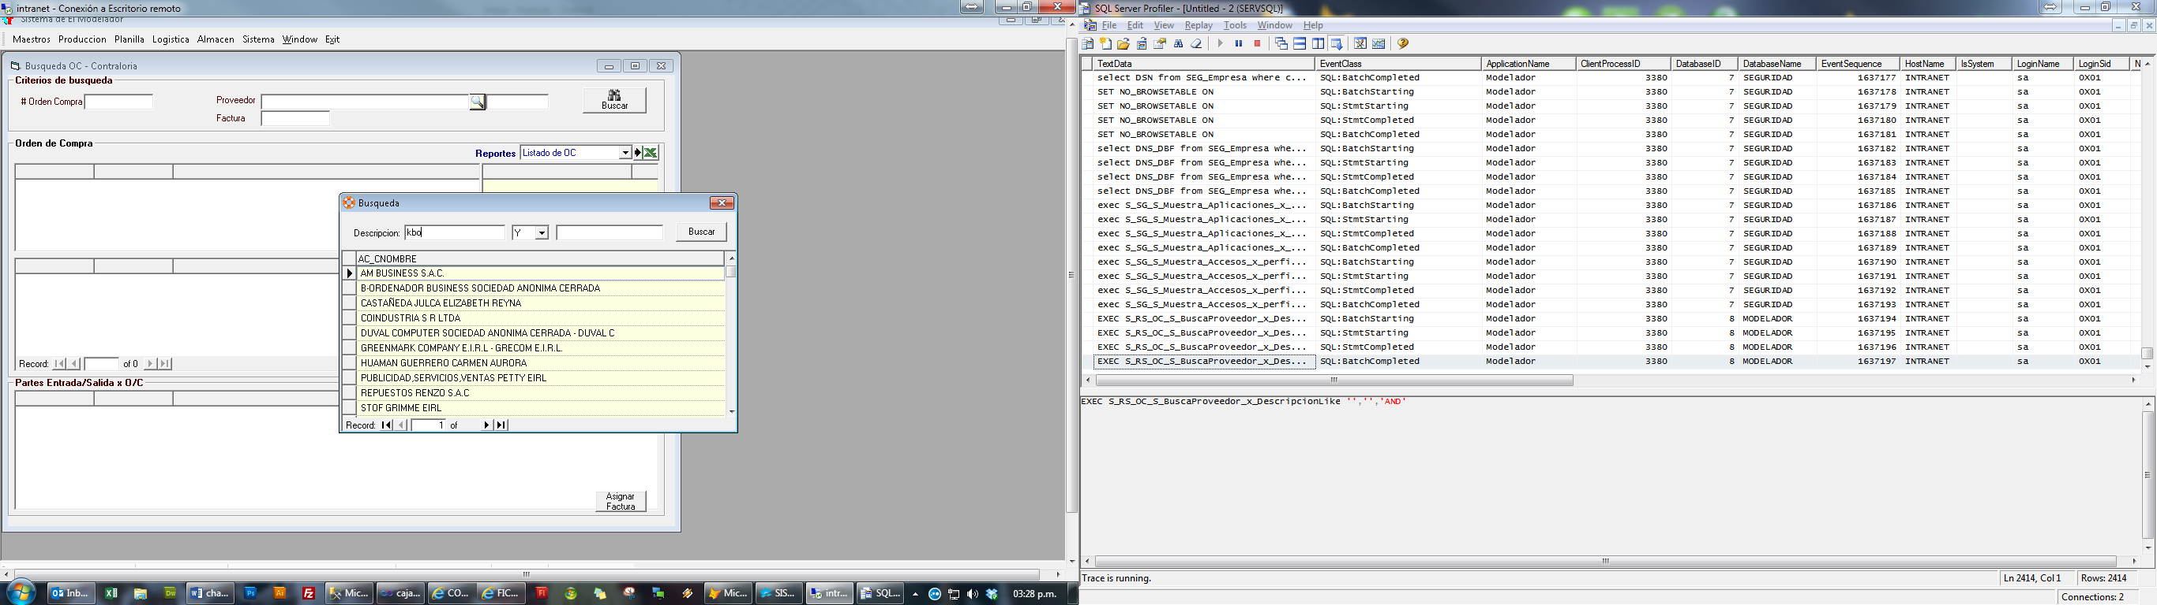

EXEC S_RS_OC_S_BuscaProveedor_x_DescripcionLike 'kbo','','AND'

EXEC RS_OC_S_BuscaOC_x_OpcionPrincipal_Contralor '','20460371032 ',''

SELECT RTRIM(A.CP_CNUMDOC) as Factura,

(A.CP_NIMPOUS-A.CP_NIGVUS) as IMPUSFT, ISNULL(IMPUSMOV,0) as IMPUSMOV,

(A.CP_NIMPOMN-A.CP_NIGVMN) as IMPMNFT, ISNULL(IMPMNMOV,0) as IMPMNMOV,

RTRIM(CP_CSUBDIA)+'-'+CP_CCOMPRO as Comprob

FROM RSCONCAR..CP0001CART A LEFT JOIN #RECIBIDOS B ON (A.CP_CNUMDOC collate SQL_Latin1_General_CP1_CI_AI=B.CP_CNUMDOC collate SQL_Latin1_General_CP1_CI_AI)

WHERE A.CP_CVANEXO='P' AND A.CP_CCODIGO=@CODPROV AND A.CP_CTIPDOC='FT' AND [A.CP_CNDOCRE=@CNUMOC](mailto:A.CP_CNDOCRE=@CNUMOC)

exec RS_OC_S_BuscaFT_x_OC_Contralor '',''

EXEC S_RS_OC_S_BuscaOC_Detalle_x_OC_Agrupado ''

Select A.OC_CCODIGO Codigo,A.AR_CDESCRI Descripcion,A.OC_CUNIDAD Unidad,A.OC_NCANORD as 'Cant.Ordenada',

ISNULL(B.C6_NCANTID,0)AS 'Cant.Entregada',(A.OC_NCANORD-ISNULL(B.C6_NCANTID,0)) 'Cant.Pendiente',

CASE WHEN A.OC_NCANORD=0 THEN 0 ELSE (ISNULL(B.C6_NCANTID,0)/A.OC_NCANORD) END '% Atendido'

From #DETALLEOC A LEFT JOIN #PARTES B ON (A.OC_CNUMORD=B.C5_CNUMORD AND A.OC_CCODIGO=B.C6_CCODIGO)

ORDER BY A.OC_CCODIGO

EXEC S_RS_OC_S_BuscaOC_Detalle_x_OC_Agrupado ''

EXEC RS_OC_S_BuscaPE_x_OC_Contralor 'XX'

exec RS_OC_S_BuscaFT_x_OC_Contralor '0000016924','20460371032 '

EXEC S_RS_OC_S_BuscaOC_Detalle_x_OC_Agrupado '0000016924'

Select A.OC_CCODIGO Codigo,A.AR_CDESCRI Descripcion,A.OC_CUNIDAD Unidad,A.OC_NCANORD as 'Cant.Ordenada',

ISNULL(B.C6_NCANTID,0)AS 'Cant.Entregada',(A.OC_NCANORD-ISNULL(B.C6_NCANTID,0)) 'Cant.Pendiente',

CASE WHEN A.OC_NCANORD=0 THEN 0 ELSE (ISNULL(B.C6_NCANTID,0)/A.OC_NCANORD) END '% Atendido'

From #DETALLEOC A LEFT JOIN #PARTES B ON (A.OC_CNUMORD=B.C5_CNUMORD AND A.OC_CCODIGO=B.C6_CCODIGO)

ORDER BY A.OC_CCODIGO

EXEC S_RS_OC_S_BuscaOC_Detalle_x_OC_Agrupado '0000016924'

EXEC RS_OC_S_BuscaPE_x_OC_Contralor '0000016924'

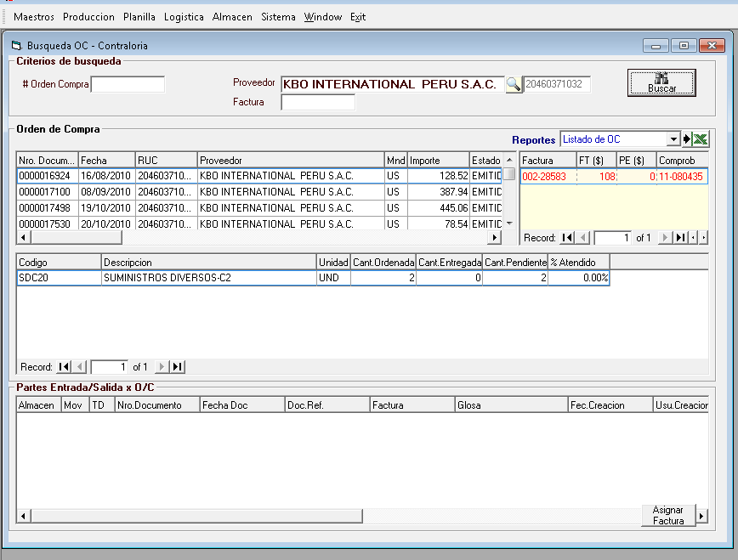

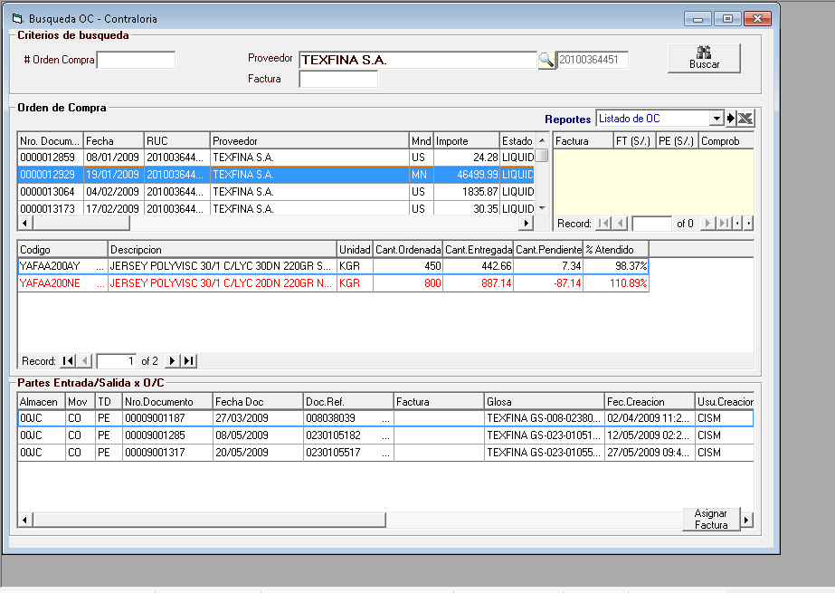

EXEC S_RS_OC_S_BuscaOC_Detalle_x_OC '0000012929'

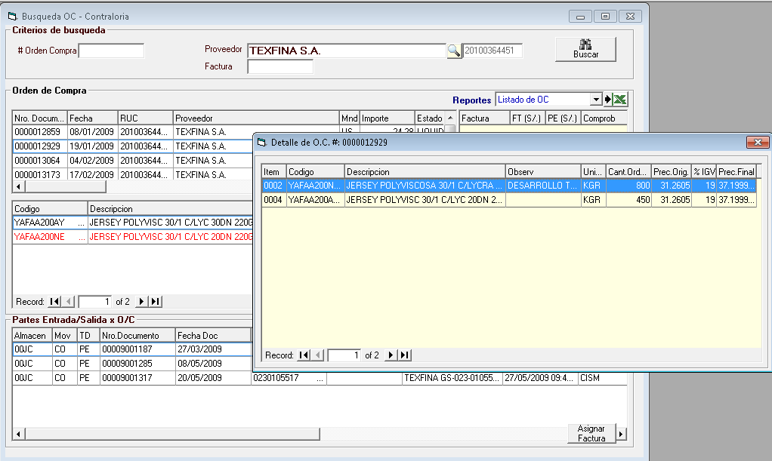

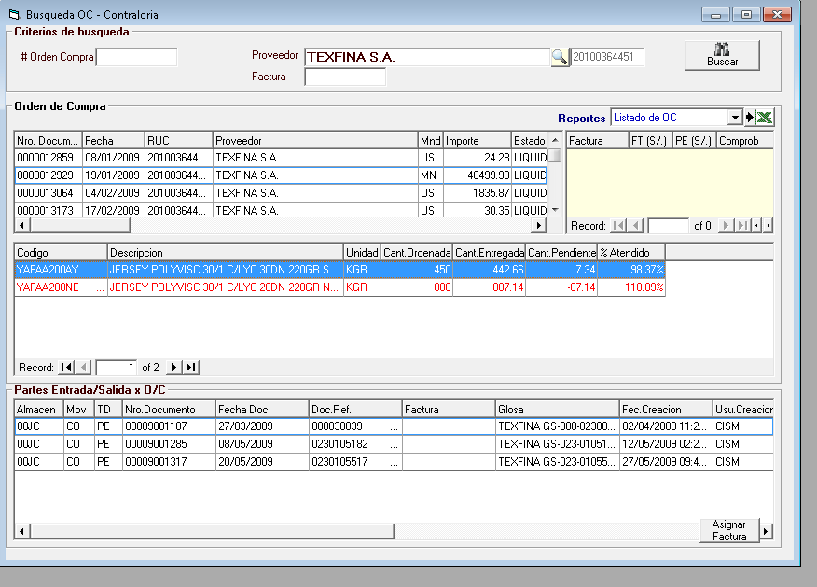

EXEC S_RS_OC_S_BuscaPE_x_Articulo '0000012929','YAFAA200AY'

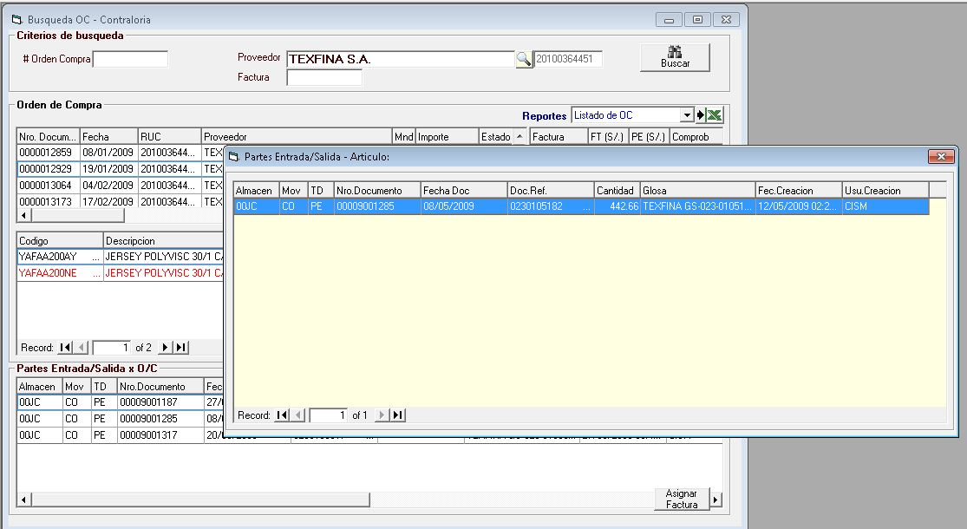

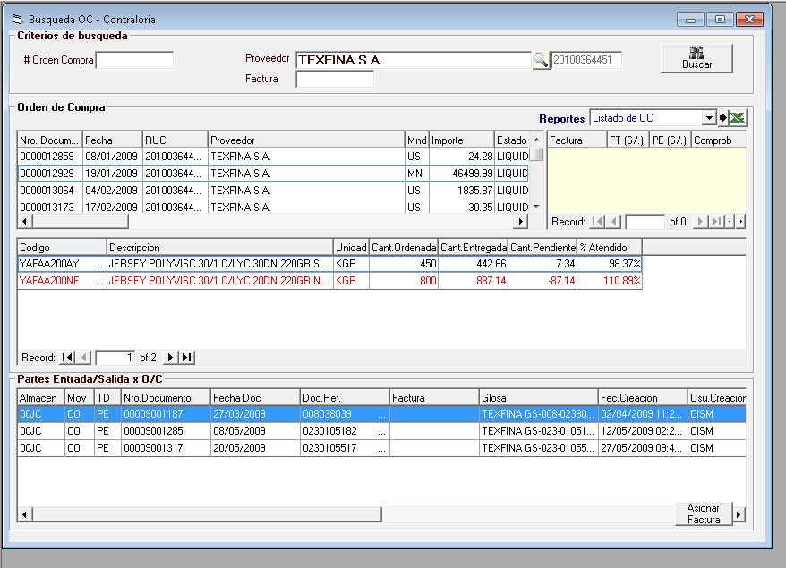

EXEC RS_OC_S_BuscaDetallePE '00MT','PE','00009016625'

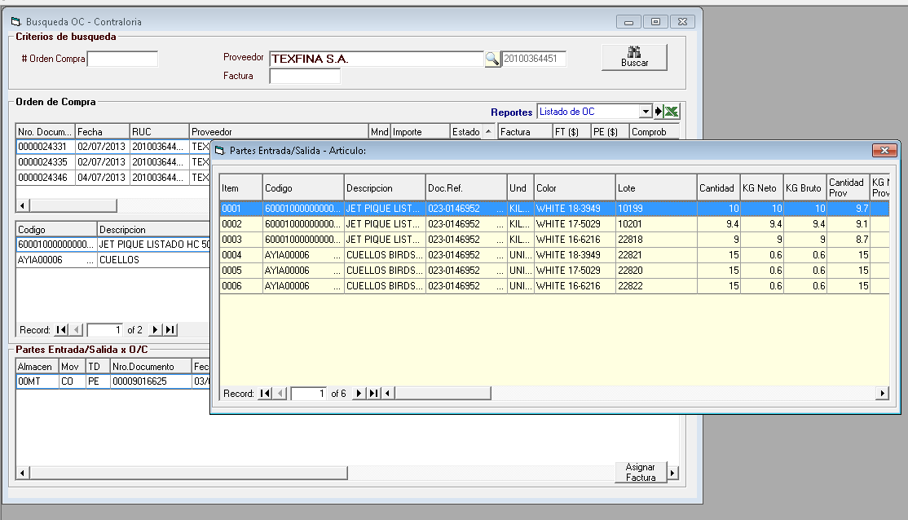

(SELECT ' ' CP_CNUMDOC) union ALL (SELECT CP_CNUMDOC FROM RSCONCAR..CP0001CART WHERE CP_CVANEXO='P' AND CP_CCODIGO='20100364451 ' AND CP_CNDOCRE='0000024331') ORDER BY 1

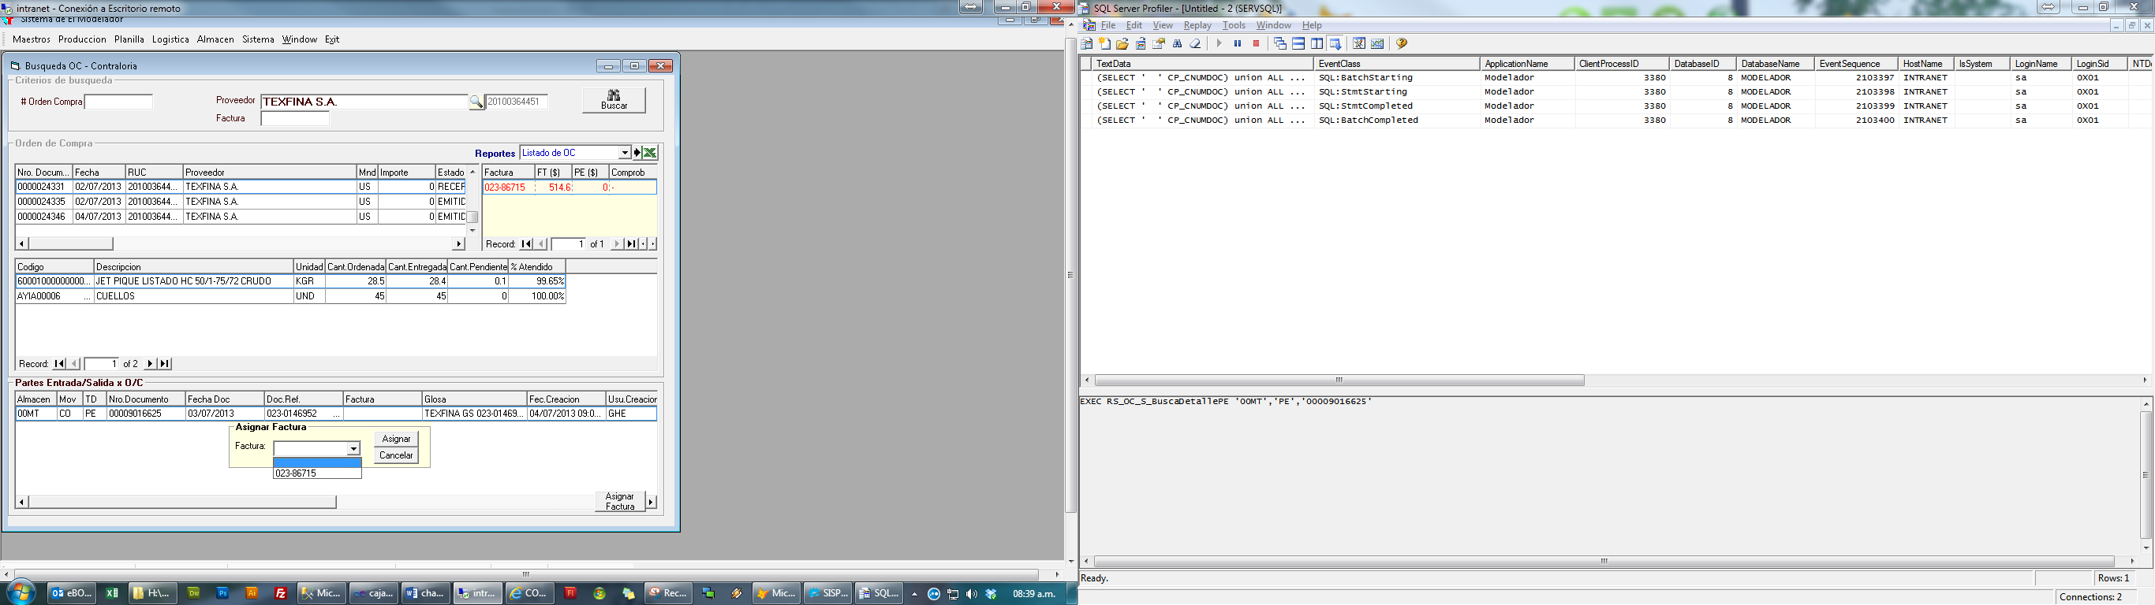

EXEC RS_OC_U_ALMOVC_FACTURA '00HD','GS','0010087021 ','FT','001-561 ','sistemas'

EXEC RS_OC_S_BuscaPE_x_OC_Contralor '0000024124'

exec RS_OC_S_BuscaFT_x_OC_Contralor '0000024124','20544012721 '

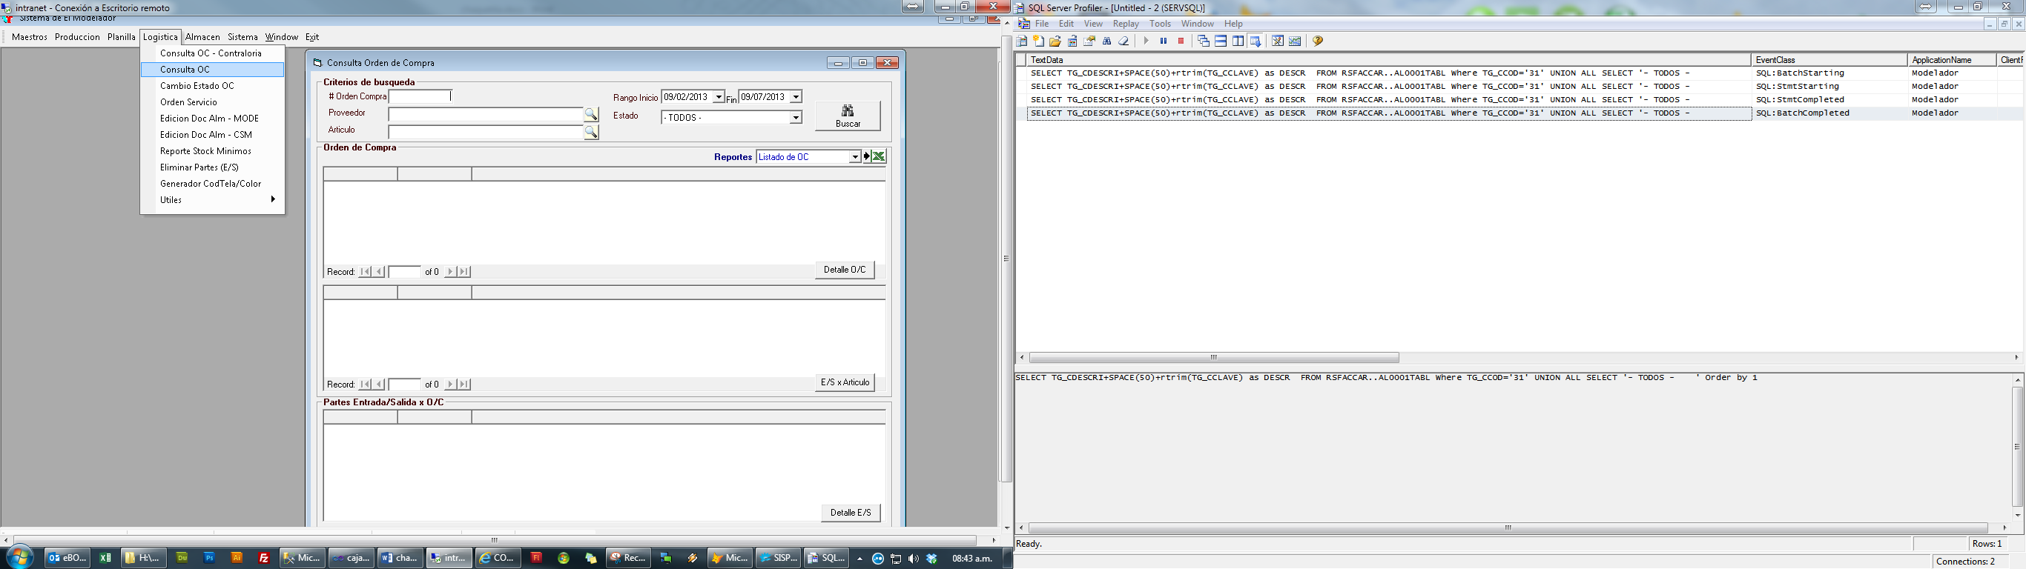

SELECT TG_CDESCRI+SPACE(50)+rtrim(TG_CCLAVE) as DESCR FROM RSFACCAR..AL0001TABL Where TG_CCOD='31' UNION ALL SELECT '- TODOS - ' Order by 1

EXEC S_RS_OC_S_BuscaOC_x_OpcionPrincipal '20130209','20130709','','','',''

EXEC S_RS_OC_S_BuscaOC_Detalle_x_OC_Agrupado ''

Select A.OC_CCODIGO Codigo,A.AR_CDESCRI Descripcion,A.OC_CUNIDAD Unidad,A.OC_NCANORD as 'Cant.Ordenada',

ISNULL(B.C6_NCANTID,0)AS 'Cant.Entregada',(A.OC_NCANORD-ISNULL(B.C6_NCANTID,0)) 'Cant.Pendiente',

CASE WHEN A.OC_NCANORD=0 THEN 0 ELSE (ISNULL(B.C6_NCANTID,0)/A.OC_NCANORD) END '% Atendido'

From #DETALLEOC A LEFT JOIN #PARTES B ON (A.OC_CNUMORD=B.C5_CNUMORD AND A.OC_CCODIGO=B.C6_CCODIGO)

ORDER BY A.OC_CCODIGO

EXEC S_RS_OC_S_BuscaOC_Detalle_x_OC_Agrupado ''

EXEC S_RS_OC_S_BuscaPE_x_OC 'XX'

EXEC S_RS_OC_S_BuscaOC_Detalle_x_OC_Agrupado '0000023450'

Select A.OC_CCODIGO Codigo,A.AR_CDESCRI Descripcion,A.OC_CUNIDAD Unidad,A.OC_NCANORD as 'Cant.Ordenada',

ISNULL(B.C6_NCANTID,0)AS 'Cant.Entregada',(A.OC_NCANORD-ISNULL(B.C6_NCANTID,0)) 'Cant.Pendiente',

CASE WHEN A.OC_NCANORD=0 THEN 0 ELSE (ISNULL(B.C6_NCANTID,0)/A.OC_NCANORD) END '% Atendido'

From #DETALLEOC A LEFT JOIN #PARTES B ON (A.OC_CNUMORD=B.C5_CNUMORD AND A.OC_CCODIGO=B.C6_CCODIGO)

ORDER BY A.OC_CCODIGO

EXEC S_RS_OC_S_BuscaOC_Detalle_x_OC_Agrupado '0000023450'

EXEC S_RS_OC_S_BuscaPE_x_OC '0000023450'

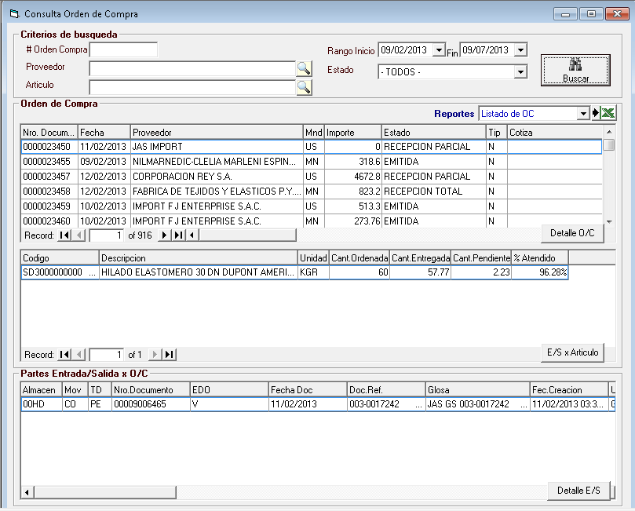

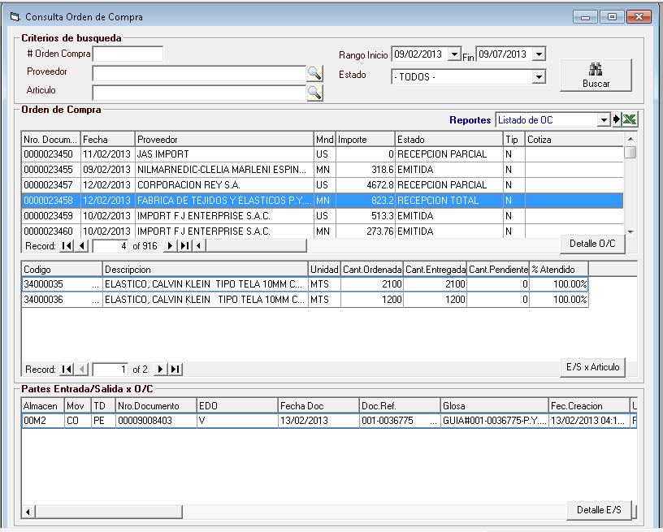

EXEC S_RS_OC_S_BuscaOC_Detalle_x_OC '0000023458'

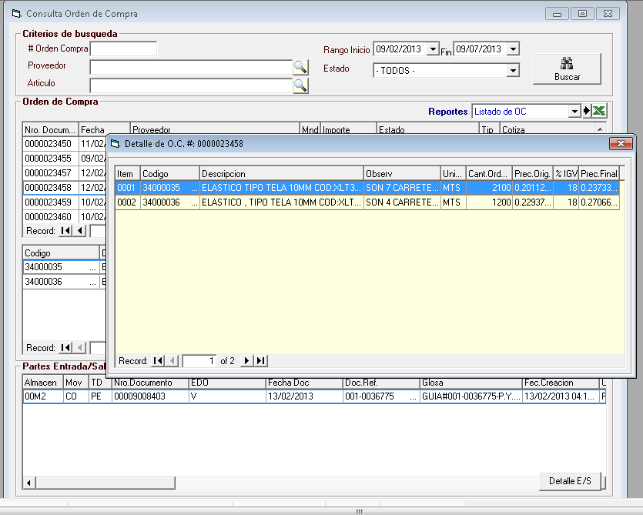

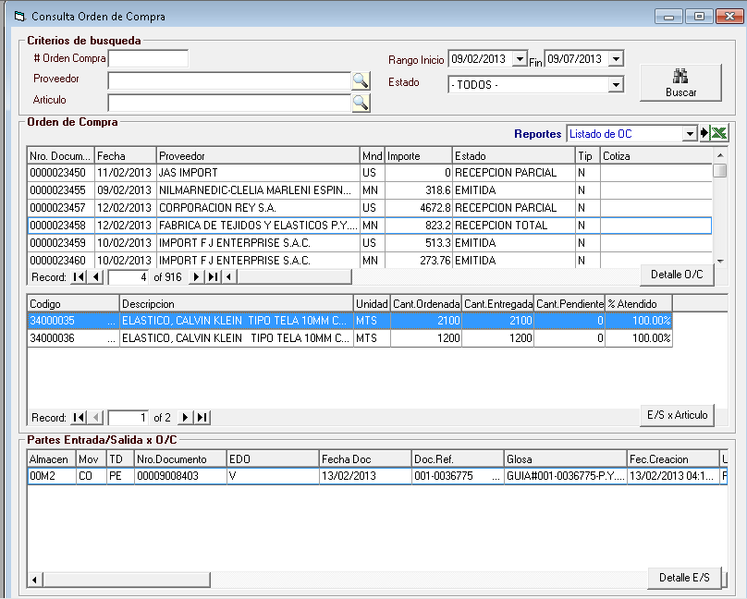

EXEC S_RS_OC_S_BuscaPE_x_Articulo '0000023458','34000035'

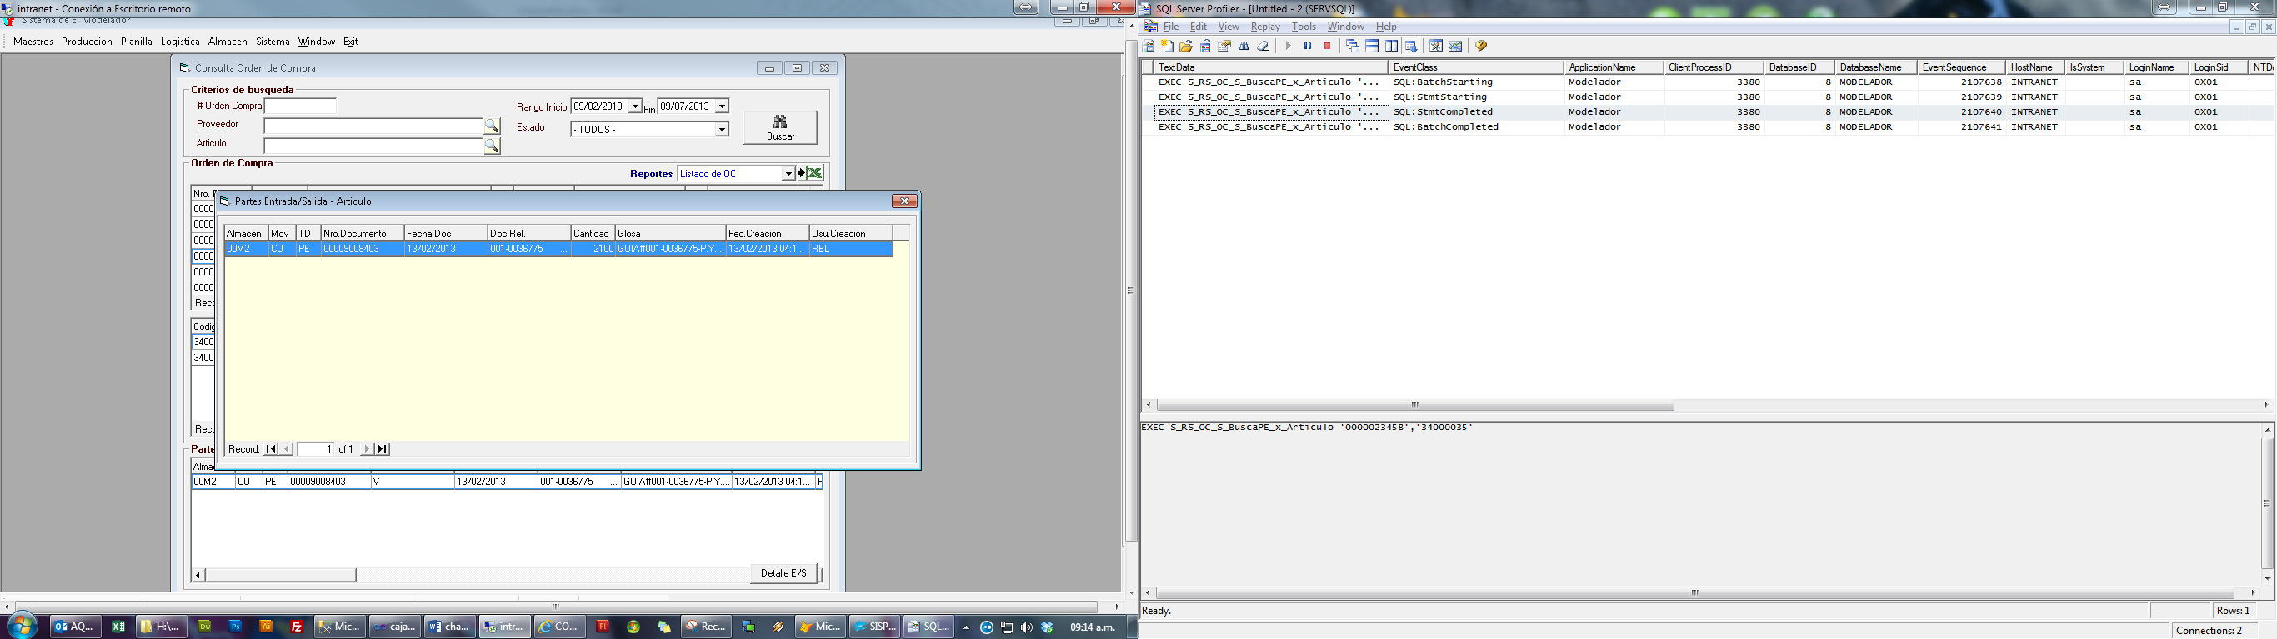

EXEC RS_OC_S_BuscaDetallePE '00M2','PE','00009008403'

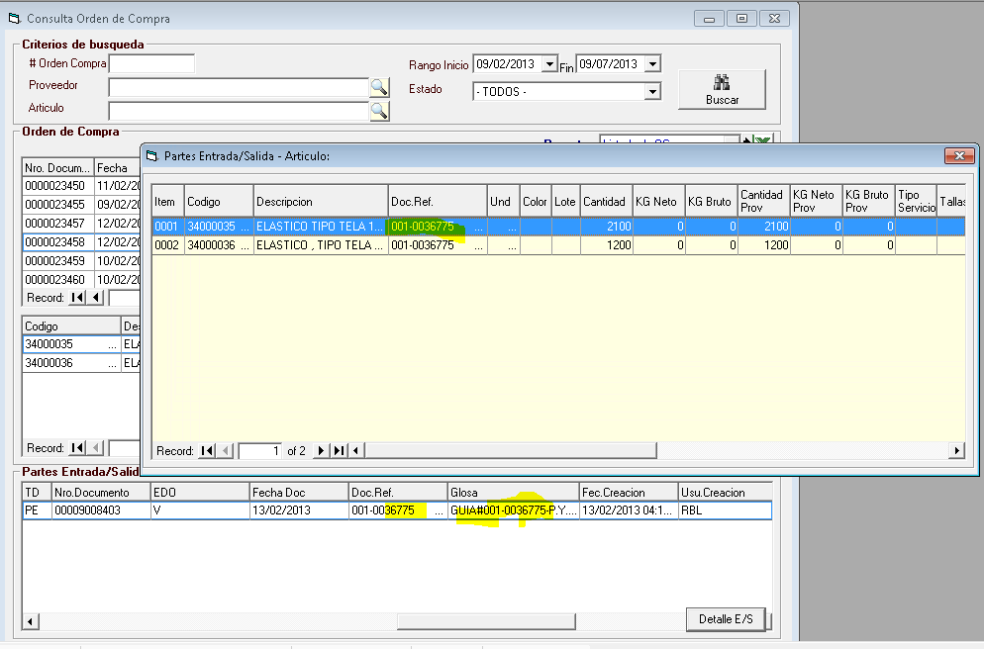

No se muestra lo que hace en el tracer……

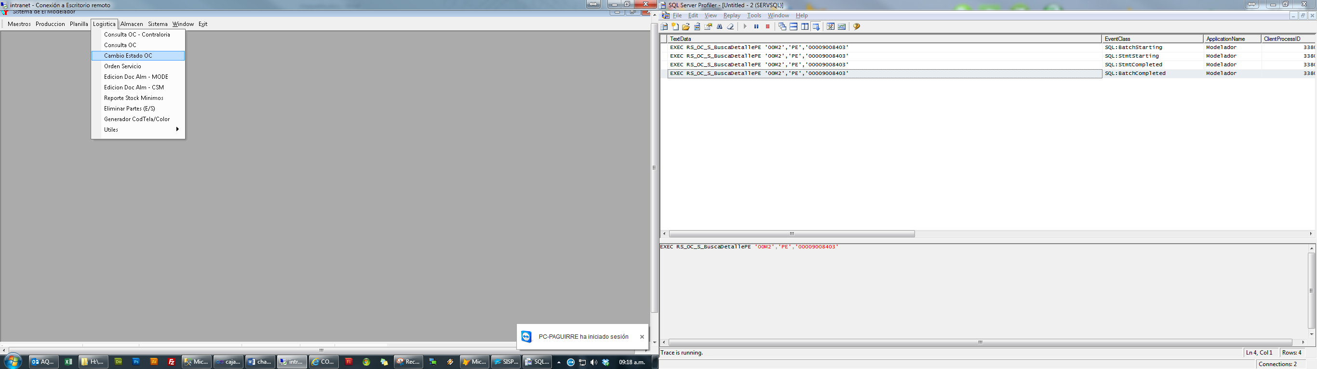 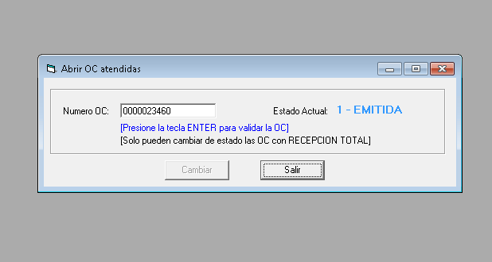

EXEC S_CM_LG_S_BuscaGuiaServ_x_OpcionPrincipal 1,'0000023452',-1,'',''

select * from EXEC S_CM_LG_S_BuscaGuiaServ_x_OpcionPrincipal 1,'0000023452',-1,'',''

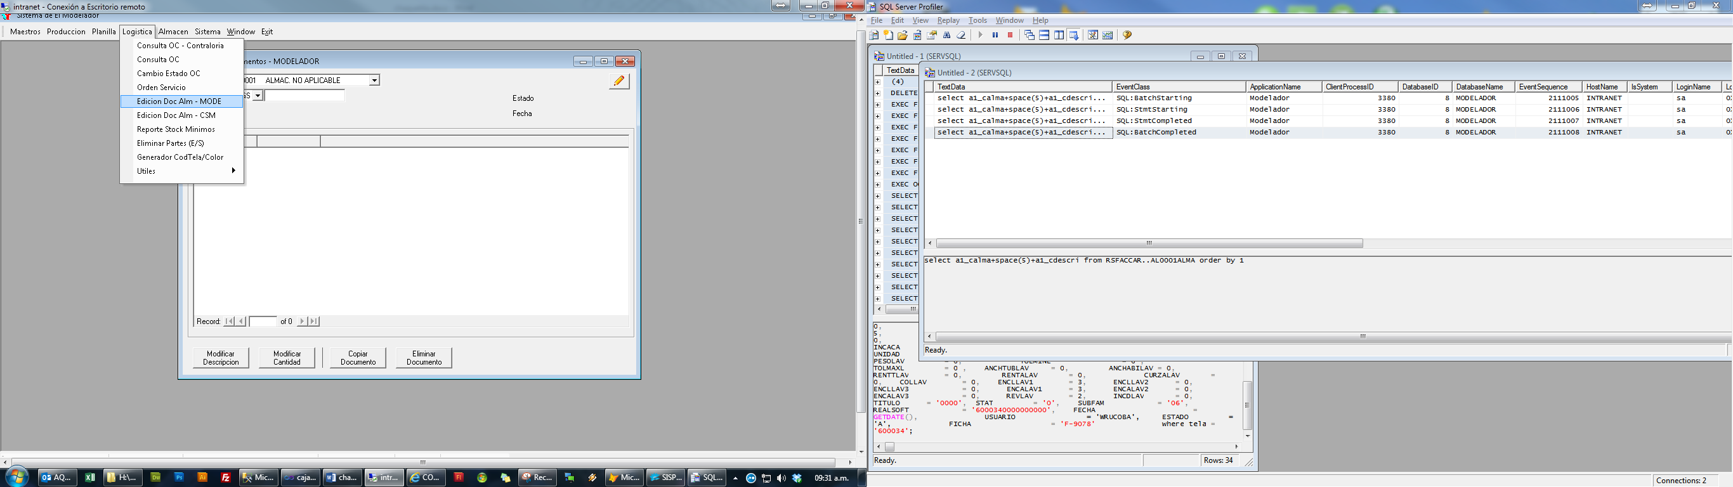 select a1_calma+space(5)+a1_cdescri from RSFACCAR..AL0001ALMA order by 1

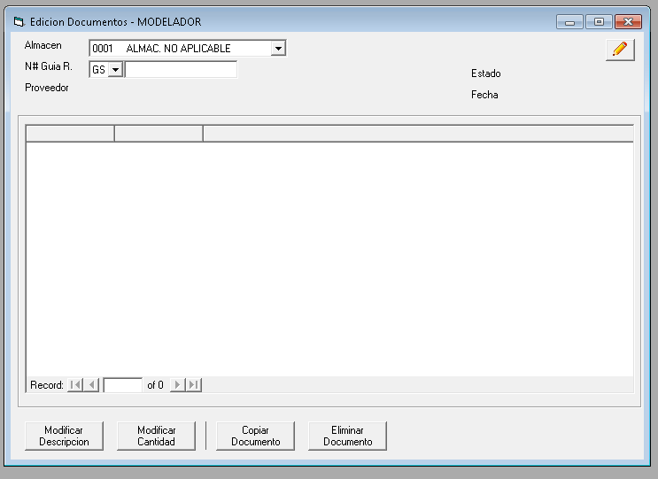

Select A.C6_CTD,A.C6_CITEM,A.C6_CCODIGO,A.C6_CDESCRI,A.C6_CCODMON,A.C6_NPREUNI,B.AR_CUNIDAD,A.C6_NCANTID From RSFACCAR..AL0001MOVD A LEFT JOIN RSFACCAR..AL0001ARTI B ON B.AR_CCODIGO=A.C6_CCODIGO

Where C6_CALMA='00M2' AND C6_CTD='PE' AND C6_CNUMDOC='00009008403' Order by C6_CALMA,C6_CTD,C6_CNUMDOC,C6_CITEM

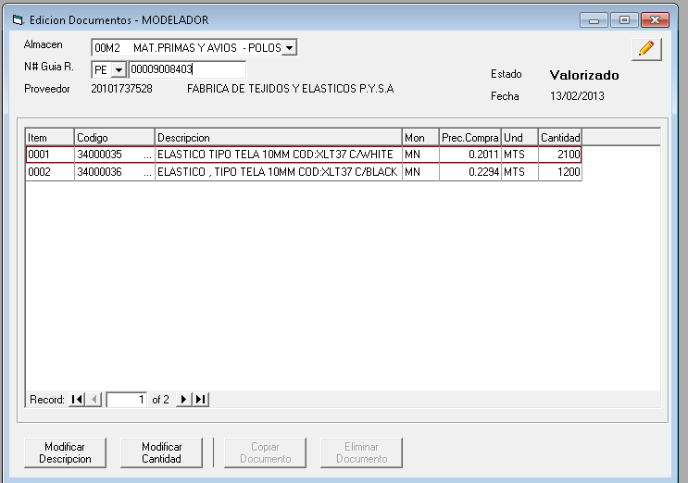

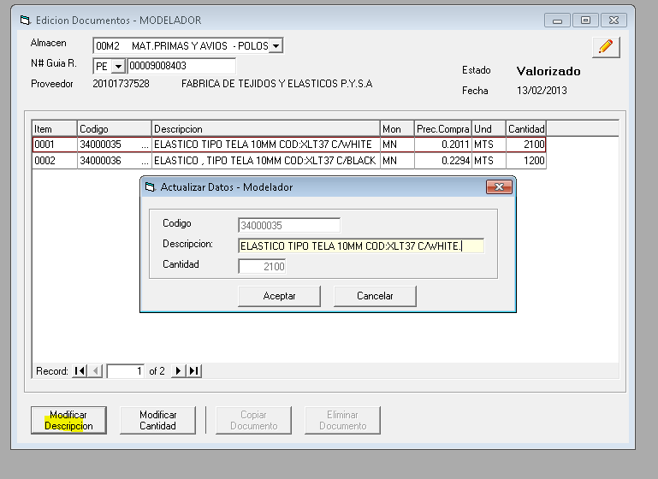

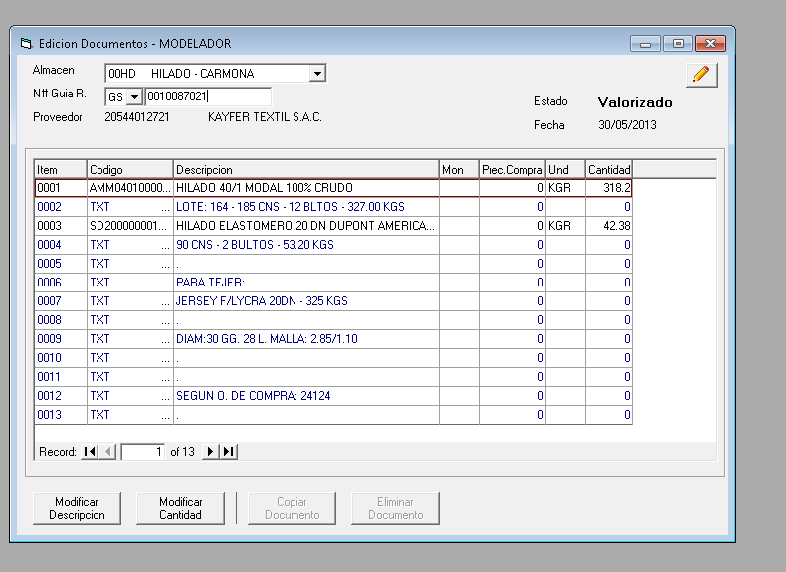

Select A.C6_CTD,A.C6_CITEM,A.C6_CCODIGO,A.C6_CDESCRI,A.C6_CCODMON,A.C6_NPREUNI,B.AR_CUNIDAD,A.C6_NCANTID From RSFACCAR..AL0001MOVD A LEFT JOIN

RSFACCAR..AL0001ARTI B ON B.AR_CCODIGO=A.C6_CCODIGO Where C6_CALMA='00HD' AND C6_CTD='GS' AND C6_CNUMDOC='0010087021' Order by

C6_CALMA,C6_CTD,C6_CNUMDOC,C6_CITEM

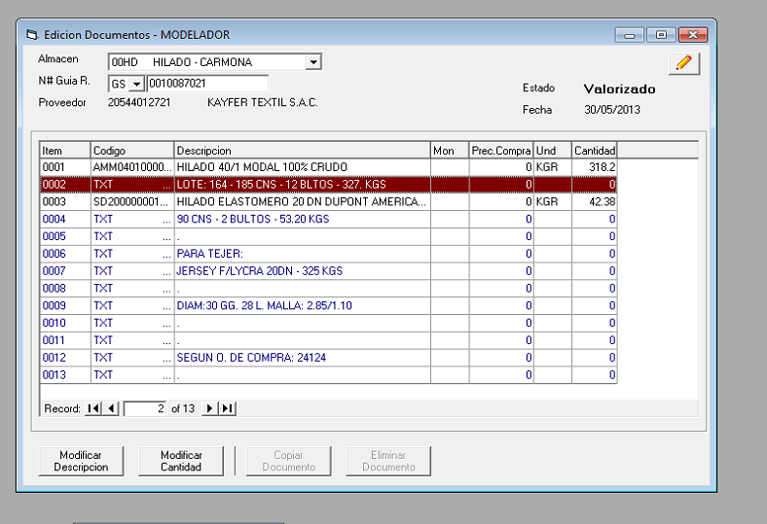

Select A.C6_CTD,A.C6_CITEM,A.C6_CCODIGO,A.C6_CDESCRI,A.C6_CCODMON,A.C6_NPREUNI,B.AR_CUNIDAD,A.C6_NCANTID From RSFACCAR..AL0001MOVD A LEFT JOIN

RSFACCAR..AL0001ARTI B ON B.AR_CCODIGO=A.C6_CCODIGO Where C6_CALMA='00HD' AND C6_CTD='GS' AND C6_CNUMDOC='0010087021' Order by

C6_CALMA,C6_CTD,C6_CNUMDOC,C6_CITEM

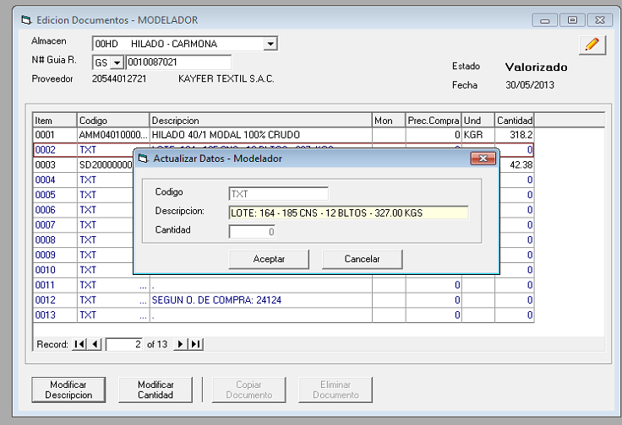

EXEC RS_GR_U_ActualizaMovAlm01 '00HD','GS','0010087021','0002','TXT ','D',0,'LOTE: 164 - 185 CNS - 12 BLTOS - 327.00 KGS'

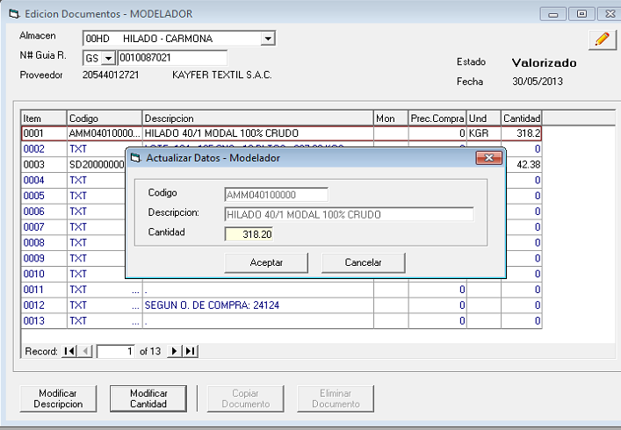

EXEC RS_GR_U_ActualizaMovAlm01 '00HD','GS','0010087021','0001','AMM040100000 ','C',318.20,'HILADO 40/1 MODAL 100% CRUDO'

Select A.C6_CTD,A.C6_CITEM,A.C6_CCODIGO,A.C6_CDESCRI,A.C6_CCODMON,A.C6_NPREUNI,B.AR_CUNIDAD,A.C6_NCANTID From RSFACCAR..AL0001MOVD A LEFT JOIN

RSFACCAR..AL0001ARTI B ON B.AR_CCODIGO=A.C6_CCODIGO Where C6_CALMA='0001' AND C6_CTD='GS' AND C6_CNUMDOC='' Order by C6_CALMA,C6_CTD,C6_CNUMDOC,C6_CITEM

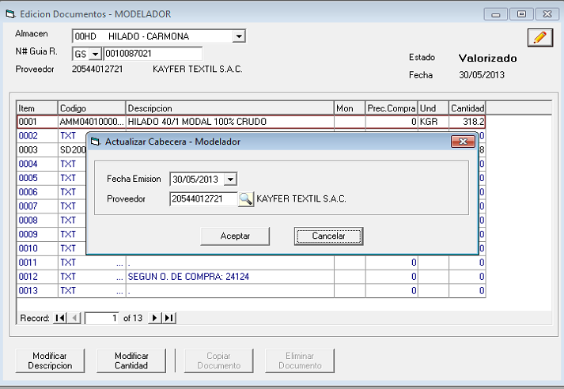

EXEC RS_GR_U_ActualizaMovAlmCab01 '00HD','GS','0010087021','20130530','20544012721'

Para poder copiar, la guía debe estar anulada

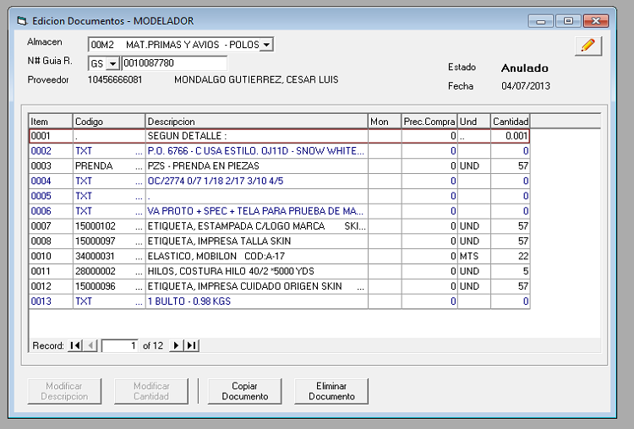

Select A.C6_CTD,A.C6_CITEM,A.C6_CCODIGO,A.C6_CDESCRI,A.C6_CCODMON,A.C6_NPREUNI,B.AR_CUNIDAD,A.C6_NCANTID From RSFACCAR..AL0001MOVD A LEFT JOIN

RSFACCAR..AL0001ARTI B ON B.AR_CCODIGO=A.C6_CCODIGO Where C6_CALMA='00M2' AND C6_CTD='GS' AND C6_CNUMDOC='0010087780' Order by

C6_CALMA,C6_CTD,C6_CNUMDOC,C6_CITEM

Select TN_CNUMSER From RSFACCAR..FT0001NUME Where TN_CCODIGO='GS' Order by TN_CNUMSER

Select TN_NNUMERO+1 From RSFACCAR..FT0001NUME Where TN_CCODIGO='GS' AND TN_CNUMSER='001 '

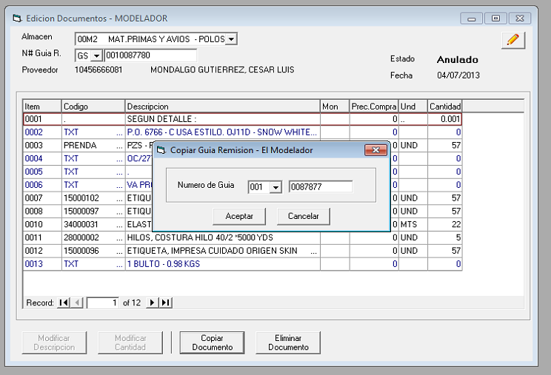

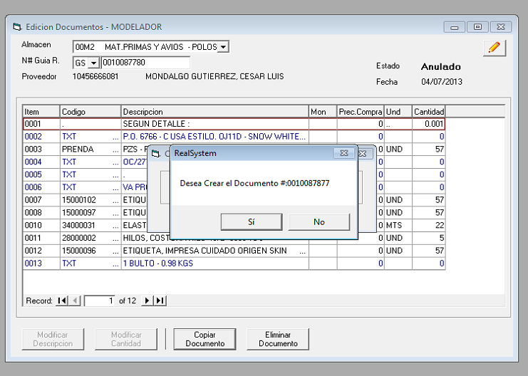

EXEC RS_GR_I_MOVALM01 '00M2','GS','0010087780','0010087877'

UPDATE #Cabecera SET C5_CNUMDOC=@CNUMDOC_NEW, C5_CSITUA='', C5_DFECCRE=getdate(),C5_DFECMOD=NULL,C5_CUSUMOD='',C5_CSITGUI='V',C5_CCODAUT=''

UPDATE #Detalle SET C6_CNUMDOC=@CNUMDOC_NEW,C6_CSITUA=''

UPDATE #Lote SET C6_CNUMDOC=@CNUMDOC_NEW

Insert RSFACCAR..AL0001MOVC

select * from #Cabecera

Insert RSFACCAR..AL0001MOVD

select * from #Detalle

Insert RSFACCAR..AL0001ASER

select * from #Lote

DECLARE CRS_STOCK CURSOR FAST_FORWARD FOR

SELECT C6_CCODIGO,SUM(C6_NCANTID) AS CANTIDAD

from #Detalle WHERE C6_CCODIGO<>'TXT' AND C6_CSTOCK='S'

GROUP BY C6_CCODIGO

Update RSFACCAR..AL0001SERI

Set SR_NSKDIS=SR_NSKDIS-B.C6_NCANTID

From RSFACCAR..AL0001SERI A INNER JOIN #stkLote B ON(A.SR_CALMA=B.C6_CALMA AND SR_CCODIGO=C6_CCODIGO AND SR_CSERIE=C6_CSERIE)

Where A.SR_CALMA=@C6_CALMA AND [A.SR_CCODIGO=@CODIGO](mailto:A.SR_CCODIGO=@CODIGO)

EXEC RS_GR_I_MOVALM01 '00M2','GS','0010087780','0010087877'

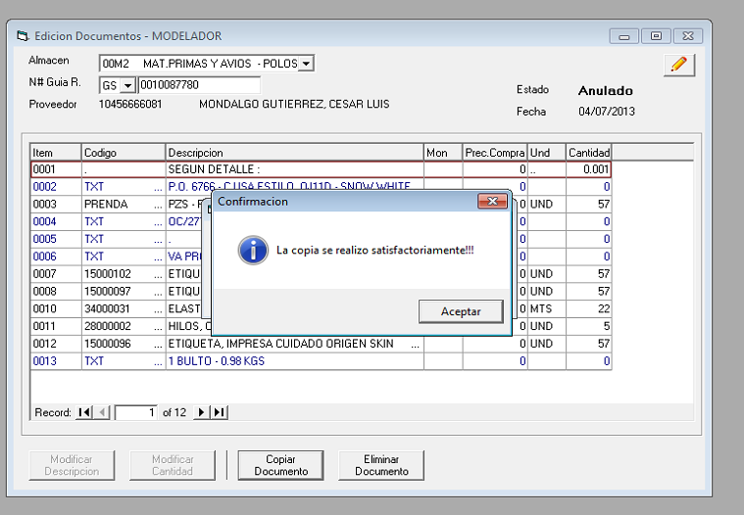

Para poder eliminar el documento en el Real primero hay que ANULAR EL DOCUMENTO

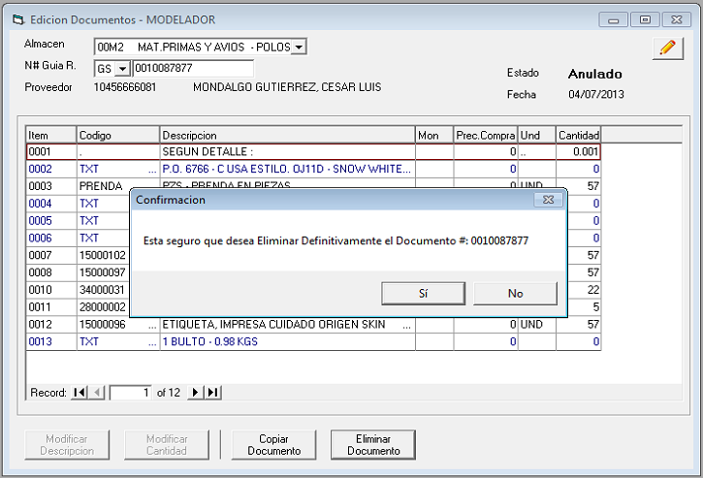

exec RS_GR_D_GUIAREMISION0001 '00M2','GS','0010087877','CGAMBOA'

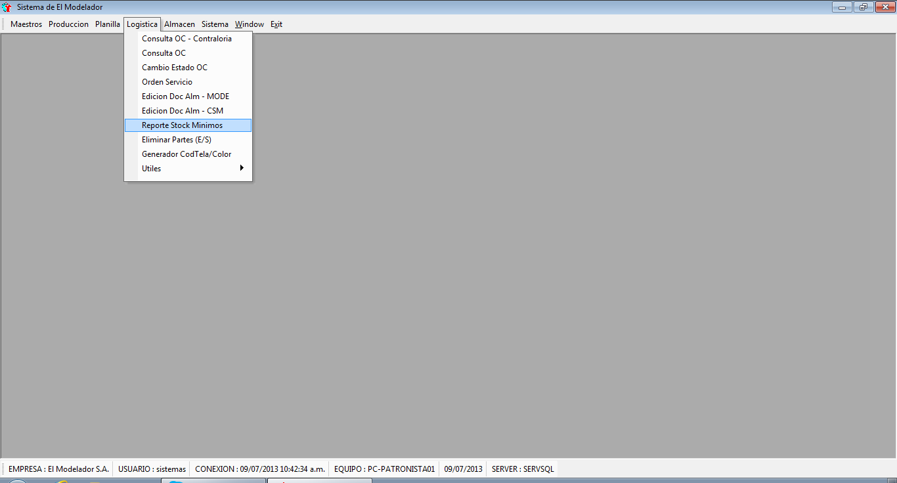 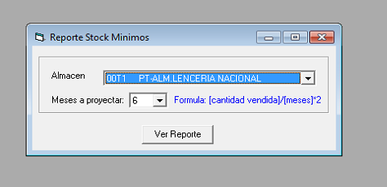

EXEC S_RS_FT_S_REP_StockMinimos '00T1',6

select * into #Docs from RSFACCAR..FT0001ACUC

WHERE F5_CALMA=@CALMA AND F5_CESTADO='V' AND F5_DFECDOC>=DATEADD(month,(@MES*-1),getdate())

select A.F6_CCODIGO as CCODIGO,SUM(F6_NCANTID)AS NCANTVEND,ROUND((SUM(F6_NCANTID)/@MES),2) AS PROMEDIO, @PROM AS STOCK

into #Ventas from RSFACCAR..FT0001ACUD A

INNER JOIN #Docs B ON(A.F6_CCODAGE=B.F5_CCODAGE AND A.F6_CTD=B.F5_CTD AND A.F6_CNUMSER=B.F5_CNUMSER AND A.F6_CNUMDOC=B.F5_CNUMDOC)

WHERE F6_CCODIGO NOT IN('TXT','DIFERENCIA','DESCUENTO','FLETE','REMBO00000','RECOST')

GROUP BY A.F6_CCODIGO

UPDATE #Ventas SET stock=sk_nskdis FROM #Ventas A inner join RSFACCAR..AL0001STOC B on(a.CCODIGO=b.sk_ccodigo)

WHERe [B.SK_CALMA=@CALMA](mailto:B.SK_CALMA=@CALMA)

select CCODIGO,ar_cdescri,NCANTVEND,stock,Promedio,(Promedio*2) as PromDoble

From #Ventas inner join RSFACCAR..AL0001ARTI on(ccodigo=ar_ccodigo)

where AR_CESTADO='V' and stock<(Promedio*2) order by CCODIGO

EXEC S_RS_FT_S_REP_StockMinimos '00T1',6

**Arroja reporte en Excel**

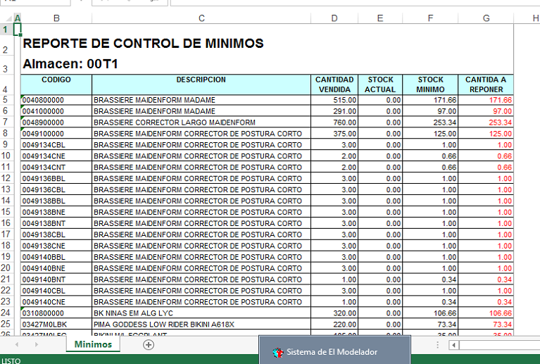

SELECT AC_CCIA+SPACE(3)+AC_CNOMCIA FROM RSFACCAR..ALCIAS ORDER BY 1

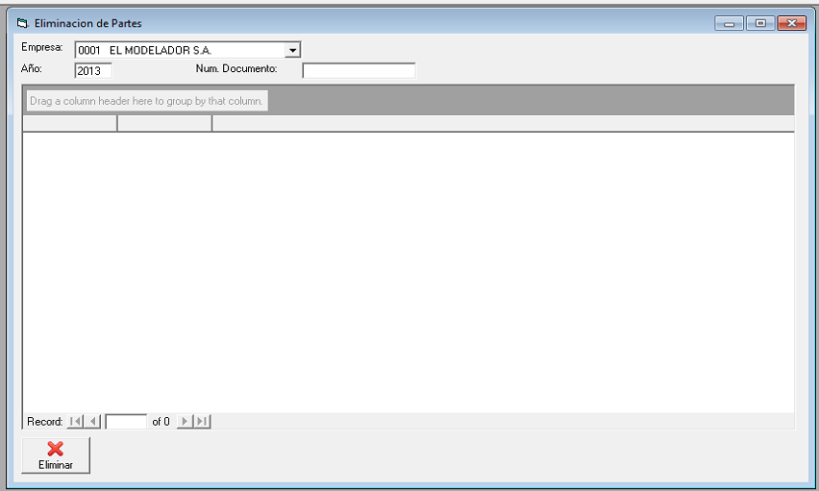

select C5_CALMA,C5_CNUMDOC,C5_CTD,C5_DFECDOC,c5_ccodmov,C5_CRFTDOC,C5_CRFNDOC,C5_CGLOSA1,C5_CGLOSA2 from RSFACCAR..AL0001MOVC where C5_CTD in ('PE','PS')

and year(c5_dfecdoc)=2013 and C5_CNUMDOC like '%00009006988' order by C5_CALMA,C5_CNUMDOC

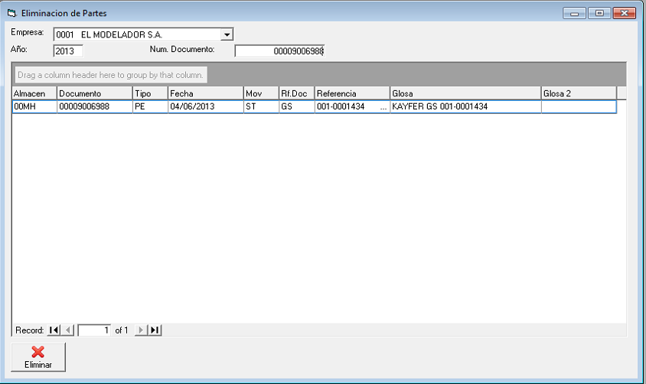

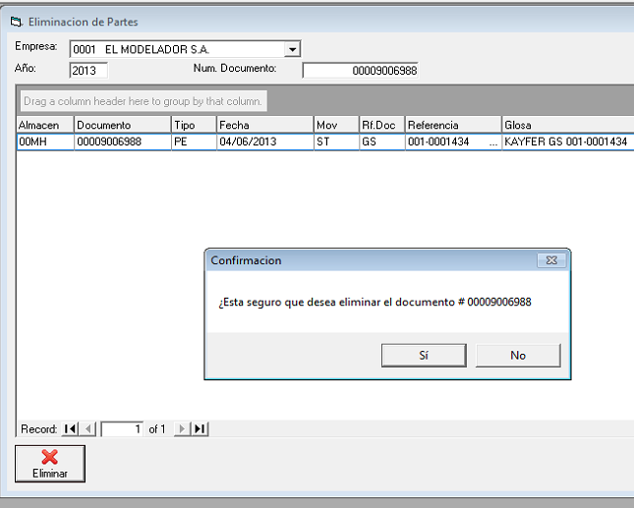

EXEC RS_MV_D_AL0001MOVC '00MH','PE','00009006988'

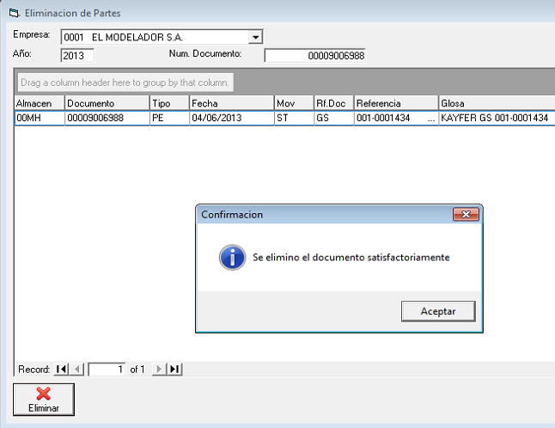

select C5_CALMA,C5_CNUMDOC,C5_CTD,C5_DFECDOC,c5_ccodmov,C5_CRFTDOC,C5_CRFNDOC,C5_CGLOSA1,C5_CGLOSA2 from RSFACCAR..AL0001MOVC where C5_CTD in ('PE','PS')

and year(c5_dfecdoc)=2013 and C5_CNUMDOC like '%00009006988' order by C5_CALMA,C5_CNUMDOC

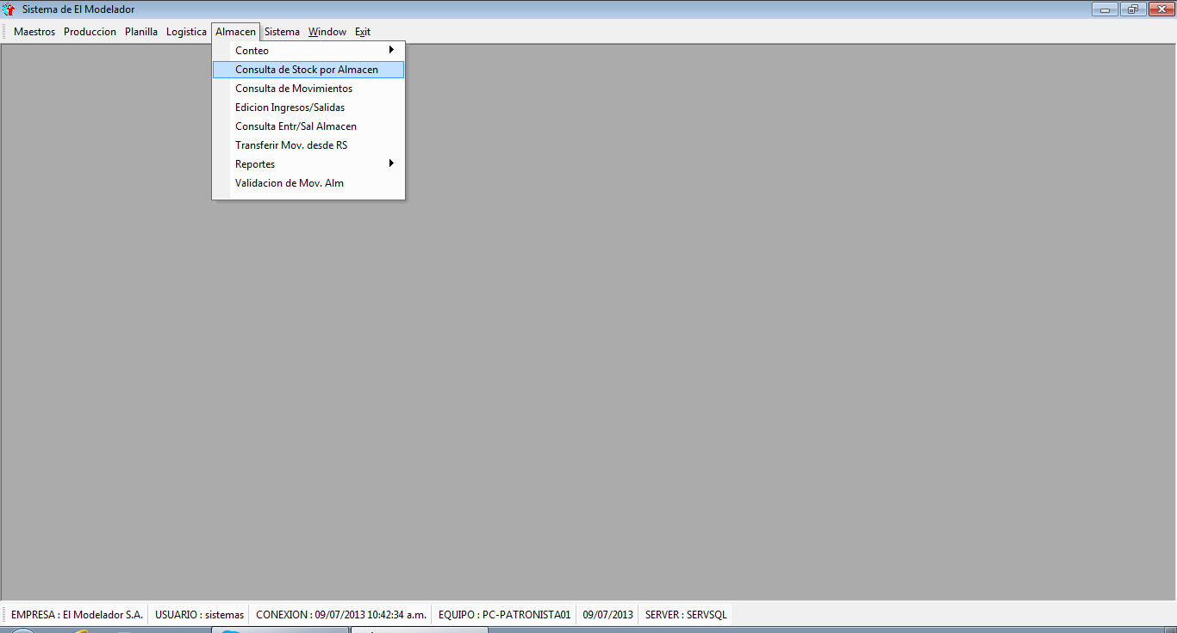(select a1_calma+space(5)+a1_cdescri from RSFACCAR..AL0001ALMA A INNER JOIN RS_USUALM B ON (A1_CALMA=CALMA) AND B.CUSUARIO='sistemas') UNION (SELECT

' - TODOS -') order by 1

(Select TG_CCLAVE+TG_CDESCRI From RSFACCAR..AL0001TABL Where TG_CCOD='15') UNION (SELECT ' - TODOS -') ORDER BY 1

Select LI_CDESLIN+space(100)+LI_CCODLIN From RSFACCAR..FT0001LINE UNION (SELECT ' - TODOS - ') ORDER BY 1

EXEC RS_ALM_S_TraerStock_x_Articulo '00H2',1,' ','','','','sistemas'

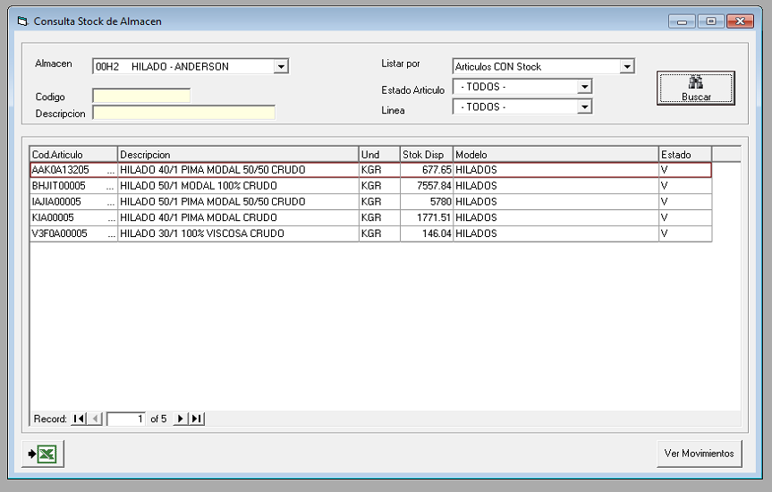

EXEC RS_MOV_S_BuscaAllMOV_x_Articulo 'AAK0A13205

SELECT B.C6_CALMA,

B.C6_DFECDOC,

B.C6_CTD,

--B.C6_CCODIGO,

B.C6_CNUMDOC+space(5) AS C6_CNUMDOC,

B.C6_CCODMOV,

A.C5_CRFTDOC,

ISNULL(CASE WHEN LEN(RTRIM(A.C5_CCODCLI))>0 THEN (SELECT CL_CNOMCLI FROM RSFACCAR..FT0001CLIE WHERE CL_CCODCLI=C5_CCODCLI) ELSE (SELECT

AC_CNOMBRE FROM RSCONCAR..CP0001MAES WHERE AC_CVANEXO='P' AND AC_CCODIGO=A.C5_CCODPRO ) END,'') AS C8RAZON,

A.C5_CRFNDOC,

B.C6_CSERIE,

B.C6_NCANTID,

A.C5_CCODMON AS C8MONE,

B.C6_NPREUNI,

CASE WHEN A.C5_CCODMON='MN' THEN B.C6_NMNIMPO ELSE B.C6_NUSIMPO END AS C8TOTAL

INTO #Movimientos

FROM RSFACCAR..AL0001MOVC A, RSFACCAR..AL0001MOVD B

WHERE A.C5_CALMA=B.C6_CALMA AND A.C5_CTD=B.C6_CTD

AND A.C5_CNUMDOC=B.C6_CNUMDOC AND NOT((B.C6_CTD='GS' AND B.C6_CCODMOV='01')

AND (A.C5_CRFTDOC IN ('BV','FT'))) AND B.C6_CSITUA<>'A' AND B.C6_CCODIGO = @CARTICULO

Insert into #Movimientos

SELECT F6_CALMA,

--F6_CCODIGO,

F6_DFECDOC,

F6_CTD,

F6_CNUMSER+'-'+F6_CNUMDOC AS F6_CNUMDOC,

' ' AS C6_CCODMOV,

' ' AS C5_CRFTDOC,

(SELECT CL_CNOMCLI FROM RSFACCAR..FT0001CLIE WHERE CL_CCODCLI=F5_CCODCLI) AS C8RAZON,

' ' AS C5_CRFNDOC,

F6_CSERIE,

F6_NCANTID,

F5_CCODMON AS C8MONE,

F6_NPRECIO,

CASE WHEN F5_CCODMON='MN' THEN F6_NIMPMN ELSE F6_NIMPUS END AS C8TOTAL

FROM RSFACCAR..FT0001ACUD INNER JOIN RSFACCAR..FT0001ACUC ON F5_CCODAGE=F6_CCODAGE AND F5_CTD=F6_CTD AND F5_CNUMSER=F6_CNUMSER AND F5_CNUMDOC=F6_CNUMDOC

WHERE F6_CCODIGO=@CARTICULO AND NOT (F6_CESTADO='A' OR F6_CSTOCK='N')

-- UNION ALL

select * from #Movimientos

order by C6_CALMA,C6_DFECDOC,C6_CTD,C6_CNUMDOC

EXEC RS_MOV_S_BuscaAllMOV_x_Articulo 'AAK0A13205 '

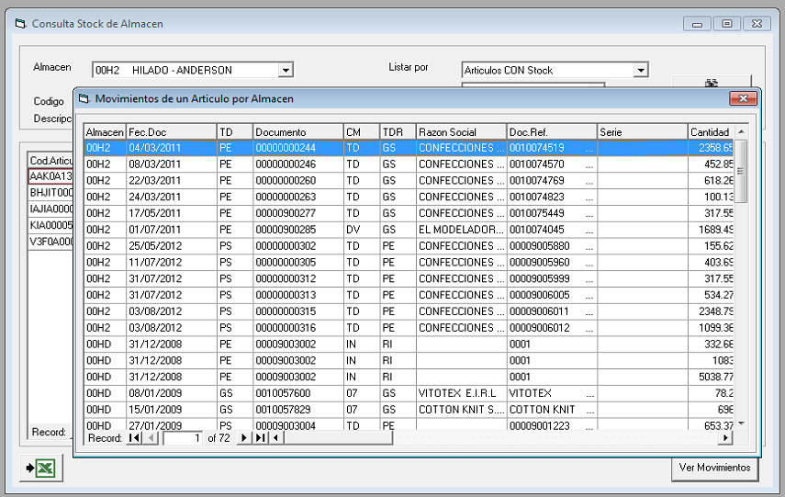

(select a1_calma+space(5)+a1_cdescri from RSFACCAR..AL0001ALMA A INNER JOIN RS_USUALM B ON (A1_CALMA=CALMA) AND B.CUSUARIO='sistemas') UNION ALL (SELECT

space(15)+' - TODOS -') order by 1

EXEC RS_MOV_S_BuscaMOVC '','S','20130709','20130709','PE','','sistemas'

EXEC RS_MOV_S_BuscaMOVD_x_MovC '','',''

EXEC RS_MOV_S_BuscaMOVD_x_MovC '00T1','PE','00009006107'

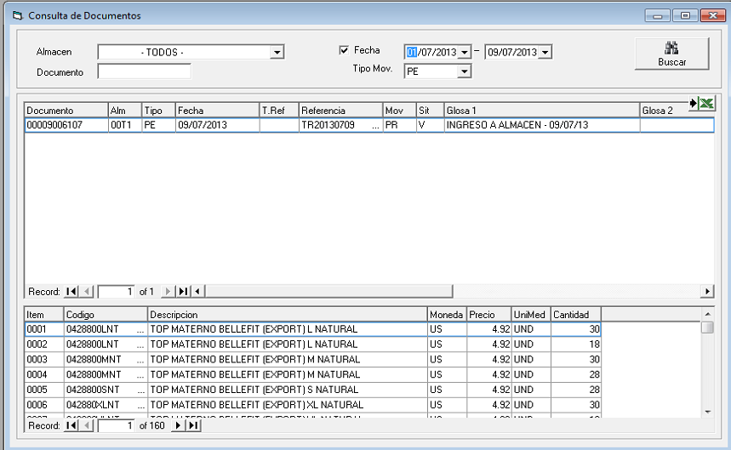

EXEC RS_MOV_S_BuscaMOVC '','S','20130701','20130709','PE','','sistemas'

EXEC RS_MOV_S_BuscaMOVD_x_MovC '','',''

EXEC RS_MOV_S_BuscaMOVD_x_MovC '00JC','PE','00009005747'

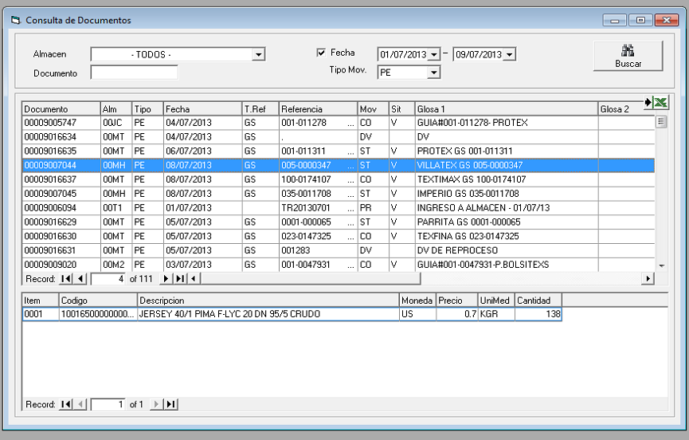

Exporta a Excel

EXEC RS_MOV_S_BuscaMOVD_x_MovC '00MH','PE','00009007044'

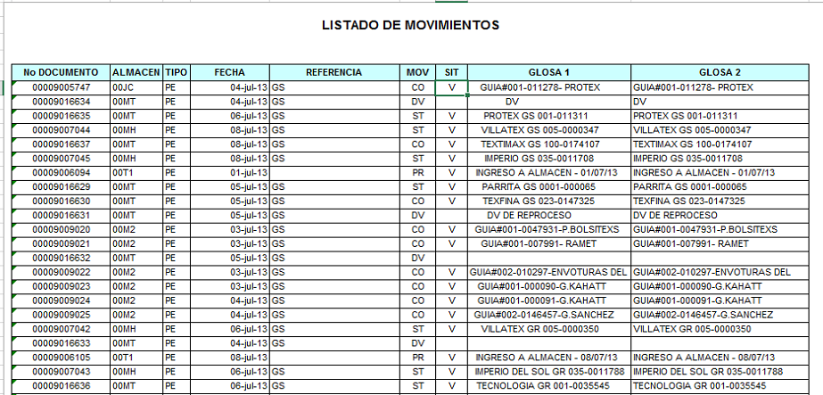

select a1_calma+space(5)+a1_cdescri from RSFACCAR..AL0001ALMA A INNER JOIN RS_USUALM B ON (A1_CALMA=CALMA) AND B.CUSUARIO='sistemas' order by 1

EXEC RS_MOV_S_ENT_SAL '00MT','00009016453','N','20130709','20130709','','','','','','','',''

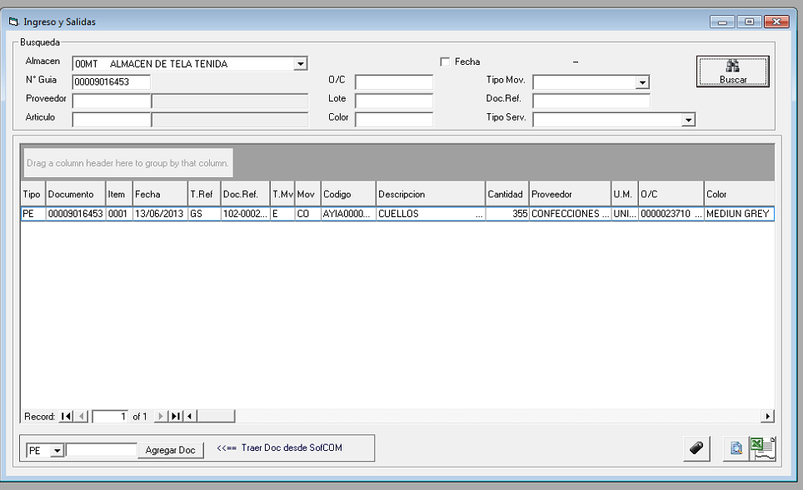

select destipomov+space(50)+codtipomov from AL_TiposMov where CodClaseMov='E' AND codtipomov in(select distinct codtipomov from AL_TipoMovxAlmacen where

codalmacen='00MT') order by 1.

select CESTANTE+ ' ['+FILA+CAST(COLUMNA AS VARCHAR(5))+']'+space(100)+cubicacion from RS_ALMOV_UBICACION where CALMA='00MT' order by CESTANTE,FILA,COLUMNA

Select Talla, Cantidad From RS_ALMOVD_TALLA Where calma='00MT' and CTD='PE' and CNUMDOC='00009016453' and CITEM='0001' ORDER BY orden

16543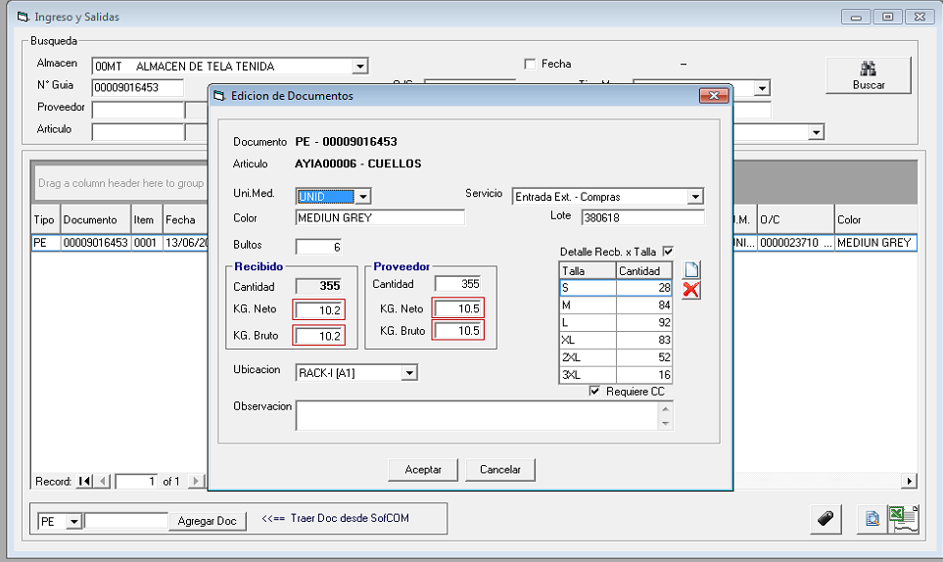

select destipomov+space(50)+codtipomov from AL_TiposMov where CodClaseMov='E' AND codtipomov in(select distinct codtipomov from AL_TipoMovxAlmacen where

codalmacen='00MT') order by 1

select CESTANTE+ ' ['+FILA+CAST(COLUMNA AS VARCHAR(5))+']'+space(100)+cubicacion from RS_ALMOV_UBICACION where CALMA='00MT' order by CESTANTE,FILA,COLUMNA

Select Talla, Cantidad From RS_ALMOVD_TALLA Where calma='00MT' and CTD='PE' and CNUMDOC='00009016453' and CITEM='0001' ORDER BY orden

EXEC RS_MOV_U_ENT_SAL_ADIC '00MT','PE','00009016453','0001','UNID','MEDIUN GREY','380618',6,0,10.2,10.2,355,10.5,10.5,'039','0100','prueba de DEMO

','S','S'

Insert into RS_ALMOVD_TALLA (CALMA,CTD,CNUMDOC,CITEM,TALLA,CANTIDAD,ORDEN) VALUES('00MT','PE','00009016453','0001','XL ',83,4)

Insert into RS_ALMOVD_TALLA (CALMA,CTD,CNUMDOC,CITEM,TALLA,CANTIDAD,ORDEN) VALUES('00MT','PE','00009016453','0001','2XL ',52,5)

Insert into RS_ALMOVD_TALLA (CALMA,CTD,CNUMDOC,CITEM,TALLA,CANTIDAD,ORDEN) VALUES('00MT','PE','00009016453','0001','3XL ',16,6)

EXEC RS_MOV_S_ENT_SAL '00MT','00009016453','N','20130709','20130709','','','','','','','',''

select count(*) from RSFACCAR..AL0001MOVC Where C5_CALMA='00MT' AND C5_CTD='PE' AND C5_CNUMDOC='00009016453' AND C5_CCODAUT='S' AND C5_CSITUA<>'A'

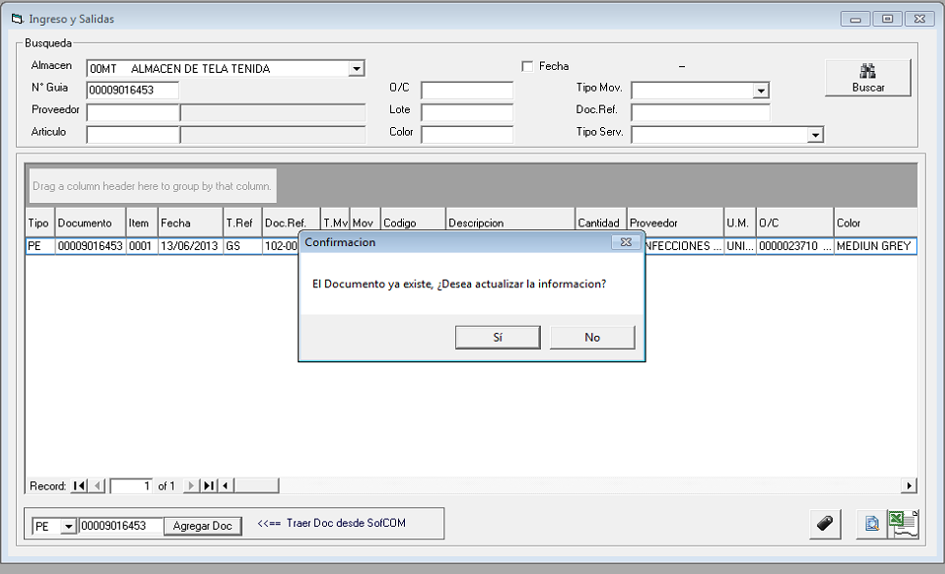

EXEC RS_MOV_U_ENT_SAL '00MT','PE','00009016453'

Select A.*

Into #MOVD

From RS_ALMOVD A INNER JOIN #CAB B ON (CALMA=C5_CALMA AND CTD=C5_CTD AND CNUMDOC=C5_CNUMDOC)

DELETE #DETALLE

WHERE C6_CCODIGO IN('TXT','.')

Insert into RS_ALMOVD(CALMA,CTD,CNUMDOC,CITEM,DFECDOC,CRFTDOC,CRFNDOC,CTIPMOV,CCODMOV,CCODIGO,CDESCRI,NCANTID,CCODPROV,CNOMPROV,CNUMORD)

Select *

From #DETALLE

UPDATE RS_ALMOVD

SET UNIMED=B.UNIMED, COLOR=B.COLOR,LOTE=B.LOTE, KGBRUTO=B.KGBRUTO,KGNETO=B.KGNETO,KGNETOPROV=B.KGNETOPROV,

KGBRUTOPROV=B.KGBRUTOPROV, BULTOS=B.BULTOS,CONOS=B.CONOS, OBSERV=B.OBSERV,CodTipoMov=B.CodTipoMov

FROM RS_ALMOVD A INNER JOIN #MOVD B ON(A.CALMA=B.CALMA AND A.CTD=B.CTD AND A.CNUMDOC=B.CNUMDOC AND A.CITEM=B.CITEM AND A.CCODIGO=B.CCODIGO)

INSERT RS_ALMOVD_TALLA

SELECT * FROM #TALLA

--select top 50 * from RS_ALMOVD

EXEC RS_MOV_U_ENT_SAL '00MT','PE','00009016453'

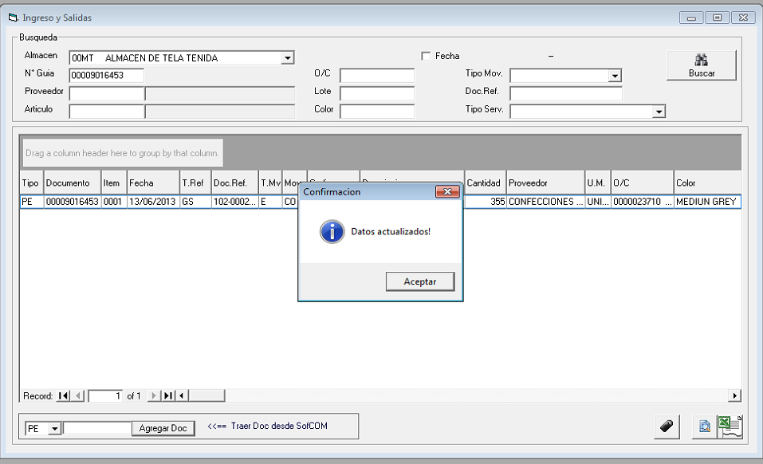

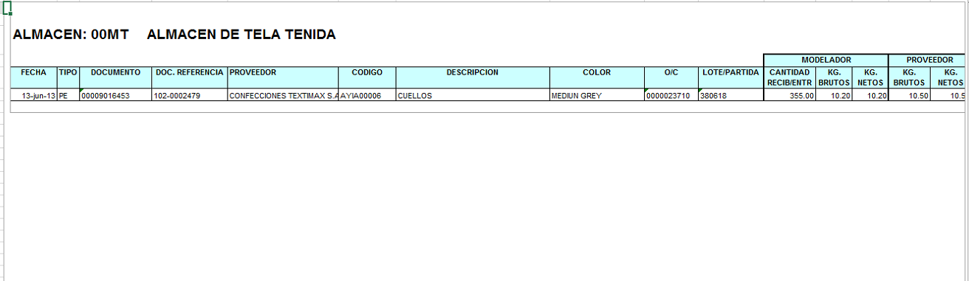

SELECT * from RSFACCAR..AL0001MOVC WHERE YEAR(C5_DFECCRE)>2010 AND C5_CCODAUT='' AND C5_CSITUA<>'A'

SELECT count(*) FROM RS_ALMOVD WHERE CALMA='00JC' AND CTD='PE' AND CNUMDOC='00009004547'

SELECT * FROM RS_ALMOVD

SELECT count(*) FROM RS_ALMOVD WHERE CALMA='00T1' AND CTD='GS' AND CNUMDOC='0120025560 '

SELECT count(*) FROM RS_ALMOVD WHERE CALMA='00JC' AND CTD='PE' AND CNUMDOC='00009004059'

SELECT count(*) FROM RS_ALMOVD WHERE CALMA='00T1' AND CTD='GS' AND CNUMDOC='0120025326 '

SELECT count(*) FROM RS_ALMOVD WHERE CALMA='00T1' AND CTD='PE' AND CNUMDOC='00009005427'

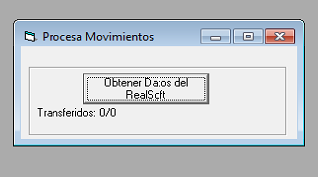

Este procedure, pasa los datos

SELECT count(*) FROM RS_ALMOVD WHERE CALMA='00JC' AND CTD='PE' AND CNUMDOC='00009004547'

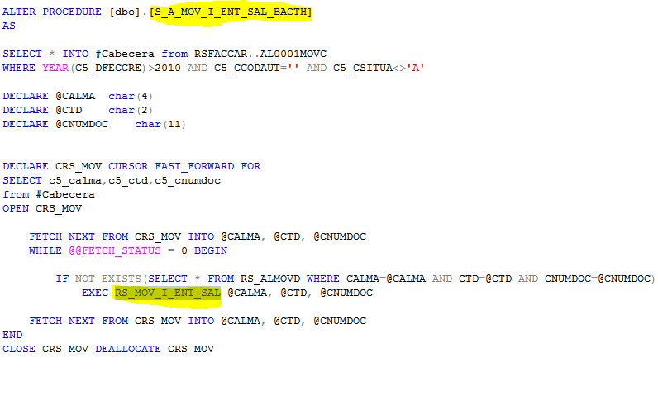

**A dónde los pasa??**

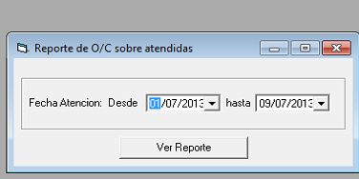

exec S_RS_OC_S_BuscaOC_SobreAtentidas '20130701','20130709'

Select A.C5_CNUMORD,B.C6_CCODIGO,SUM(B.C6_NCANTID) C6_NCANTID,A.C5_CNOMPRO,c5_dfecdoc

INTO #PARTES

From #MOVC A INNER JOIN RSFACCAR..AL0001MOVD B ON(A.C5_CALMA=B.C6_CALMA AND A.C5_CTD=B.C6_CTD AND A.C5_CNUMDOC=B.C6_CNUMDOC)

WHERE C6_CCODIGO NOT IN('TXT','.')

GROUP BY A.C5_CNUMORD,B.C6_CCODIGO,A.C5_CNOMPRO,a.c5_dfecdoc

Select A.OC_CNUMORD,A.OC_CCODIGO,B.AR_CDESCRI,A.OC_CUNIDAD,SUM(A.OC_NCANORD) OC_NCANORD

INTO #DETALLEOC

From RSFACCAR..CO0001MOVD A INNER JOIN RSFACCAR..AL0001ARTI B ON(A.OC_CCODIGO=B.AR_CCODIGO)

WHERE A.OC_CNUMORD IN (SELECT DISTINCT c5_cnumord FROM #MOVC)

GROUP BY A.OC_CCODIGO,B.AR_CDESCRI,A.OC_CUNIDAD,A.OC_CNUMORD

Select B.C5_CNUMORD,A.OC_CCODIGO Codigo,A.AR_CDESCRI Descripcion,

A.OC_CUNIDAD Unidad,A.OC_NCANORD as 'Cant.Ordenada',

ISNULL(B.C6_NCANTID,0)AS 'Cant.Entregada',

(ISNULL(B.C6_NCANTID,0)/A.OC_NCANORD) '% Atendido',c5_dfecdoc,

B.C5_CNOMPRO

From #DETALLEOC A LEFT JOIN #PARTES B ON (A.OC_CNUMORD=B.C5_CNUMORD AND A.OC_CCODIGO=B.C6_CCODIGO)

WHERE (ISNULL(B.C6_NCANTID,0)/A.OC_NCANORD)>1.05

ORDER BY B.C5_CNUMORD,A.OC_CCODIGO

exec S_RS_OC_S_BuscaOC_SobreAtentidas '20130701','20130709'

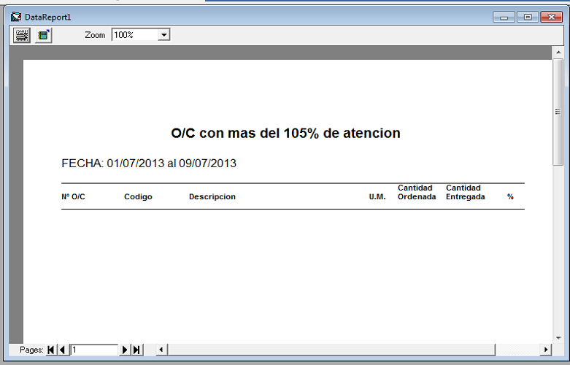

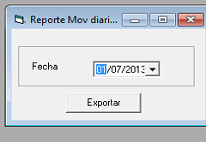

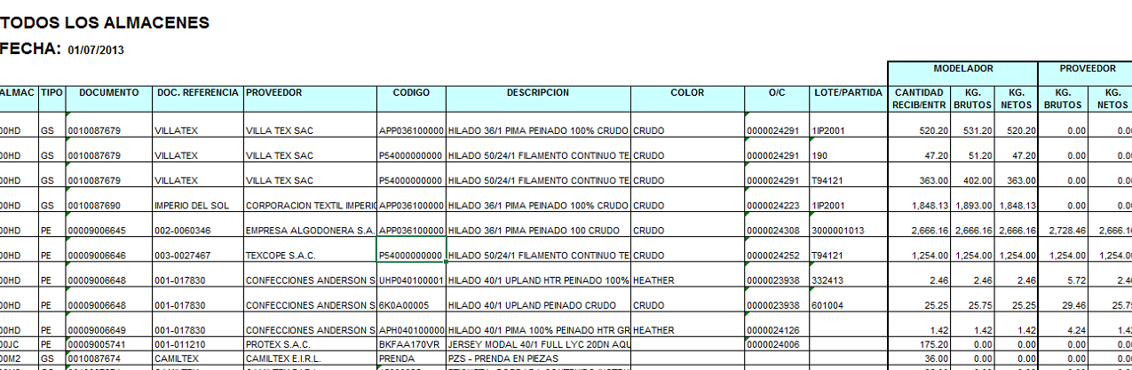

SELECT 1 Se,A.CALMA,A.CTD,A.CNUMDOC,A.CITEM,A.DFECDOC,A.CTIPMOV,A.CCODMOV,A.CCODIGO,A.CDESCRI FROM RS_ALMOVD A LEFT JOIN RSFACCAR..AL0001MOVD B ON(A.CALMA=B.C6_CALMA AND A.CTD=B.C6_CTD AND

A.CNUMDOC=B.C6_CNUMDOC AND A.CITEM=B.C6_CITEM) WHERE Year(dfecdoc)=2013 AND month(dfecdoc)=7 AND B.C6_CALMA IS NULL

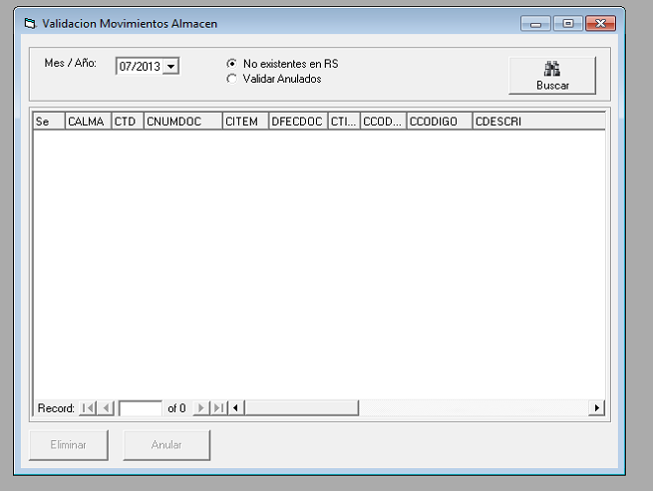

SELECT 1 Se,A.CALMA,A.CTD,A.CNUMDOC,A.CITEM,A.DFECDOC,A.CTIPMOV,A.CCODMOV,A.CCODIGO,A.CDESCRI FROM RS_ALMOVD A LEFT JOIN RSFACCAR..AL0001MOVD B ON(A.CALMA=B.C6_CALMA AND A.CTD=B.C6_CTD AND

A.CNUMDOC=B.C6_CNUMDOC AND A.CITEM=B.C6_CITEM) WHERE Year(dfecdoc)=2013 AND month(dfecdoc)=6 AND B.C6_CALMA IS NULL

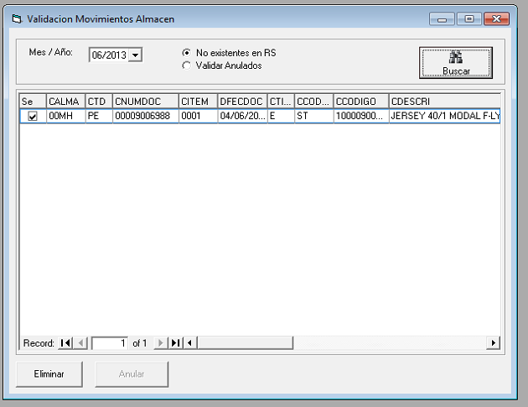

select count(*) from RS_ALMOVD_TALLA Where CALMA='00MH' AND CTD='PE' AND CNUMDOC='00009006988' AND CITEM='0001'

Delete RS_ALMOVD WHERE CALMA='00MH' AND CTD='PE' AND CNUMDOC='00009006988' AND CITEM='0001'

SELECT 1 Se,A.CALMA,A.CTD,A.CNUMDOC,A.CITEM,A.DFECDOC,A.CTIPMOV,A.CCODMOV,A.CCODIGO,A.CDESCRI FROM RS_ALMOVD A LEFT JOIN RSFACCAR..AL0001MOVD B ON(A.CALMA=B.C6_CALMA AND A.CTD=B.C6_CTD AND

A.CNUMDOC=B.C6_CNUMDOC AND A.CITEM=B.C6_CITEM) WHERE Year(dfecdoc)=2013 AND month(dfecdoc)=6 AND B.C6_CALMA IS NULL

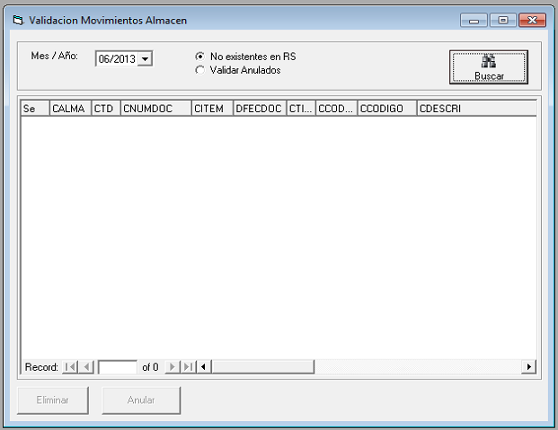

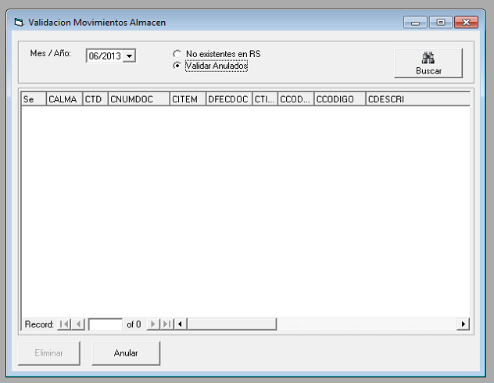

SELECT 1 Se,A.CALMA,A.CTD,A.CNUMDOC,A.CITEM,A.DFECDOC,A.CTIPMOV,A.CCODMOV,A.CCODIGO,A.CDESCRI FROM RS_ALMOVD A LEFT JOIN RSFACCAR..AL0001MOVD B ON(A.CALMA=B.C6_CALMA AND A.CTD=B.C6_CTD AND

A.CNUMDOC=B.C6_CNUMDOC AND A.CITEM=B.C6_CITEM) WHERE A.ESTADO='V' AND B.C6_CSITUA='A' AND Year(dfecdoc)=2013 AND month(dfecdoc)=7

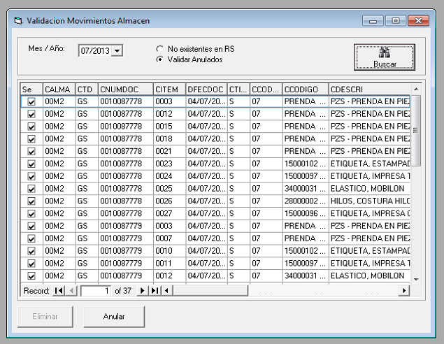

SELECT 1 Se,A.CALMA,A.CTD,A.CNUMDOC,A.CITEM,A.DFECDOC,A.CTIPMOV,A.CCODMOV,A.CCODIGO,A.CDESCRI FROM RS_ALMOVD A LEFT JOIN RSFACCAR..AL0001MOVD B ON(A.CALMA=B.C6_CALMA AND A.CTD=B.C6_CTD AND

A.CNUMDOC=B.C6_CNUMDOC AND A.CITEM=B.C6_CITEM) WHERE Year(dfecdoc)=2013 AND month(dfecdoc)=7 AND B.C6_CALMA IS NULL

SELECT 1 Se,A.CALMA,A.CTD,A.CNUMDOC,A.CITEM,A.DFECDOC,A.CTIPMOV,A.CCODMOV,A.CCODIGO,A.CDESCRI FROM RS_ALMOVD A LEFT JOIN RSFACCAR..AL0001MOVD B ON(A.CALMA=B.C6_CALMA AND A.CTD=B.C6_CTD AND

A.CNUMDOC=B.C6_CNUMDOC AND A.CITEM=B.C6_CITEM) WHERE A.ESTADO='V' AND B.C6_CSITUA='A' AND Year(dfecdoc)=2013 AND month(dfecdoc)=7

UPDATE RS_ALMOVD SET ESTADO='A' WHERE CALMA='00M2' AND CTD='GS' AND CNUMDOC='0010087778 ' AND CITEM='0003'

UPDATE RS_ALMOVD SET ESTADO='A' WHERE CALMA='00M2' AND CTD='GS' AND CNUMDOC='0010087778 ' AND CITEM='0012'

